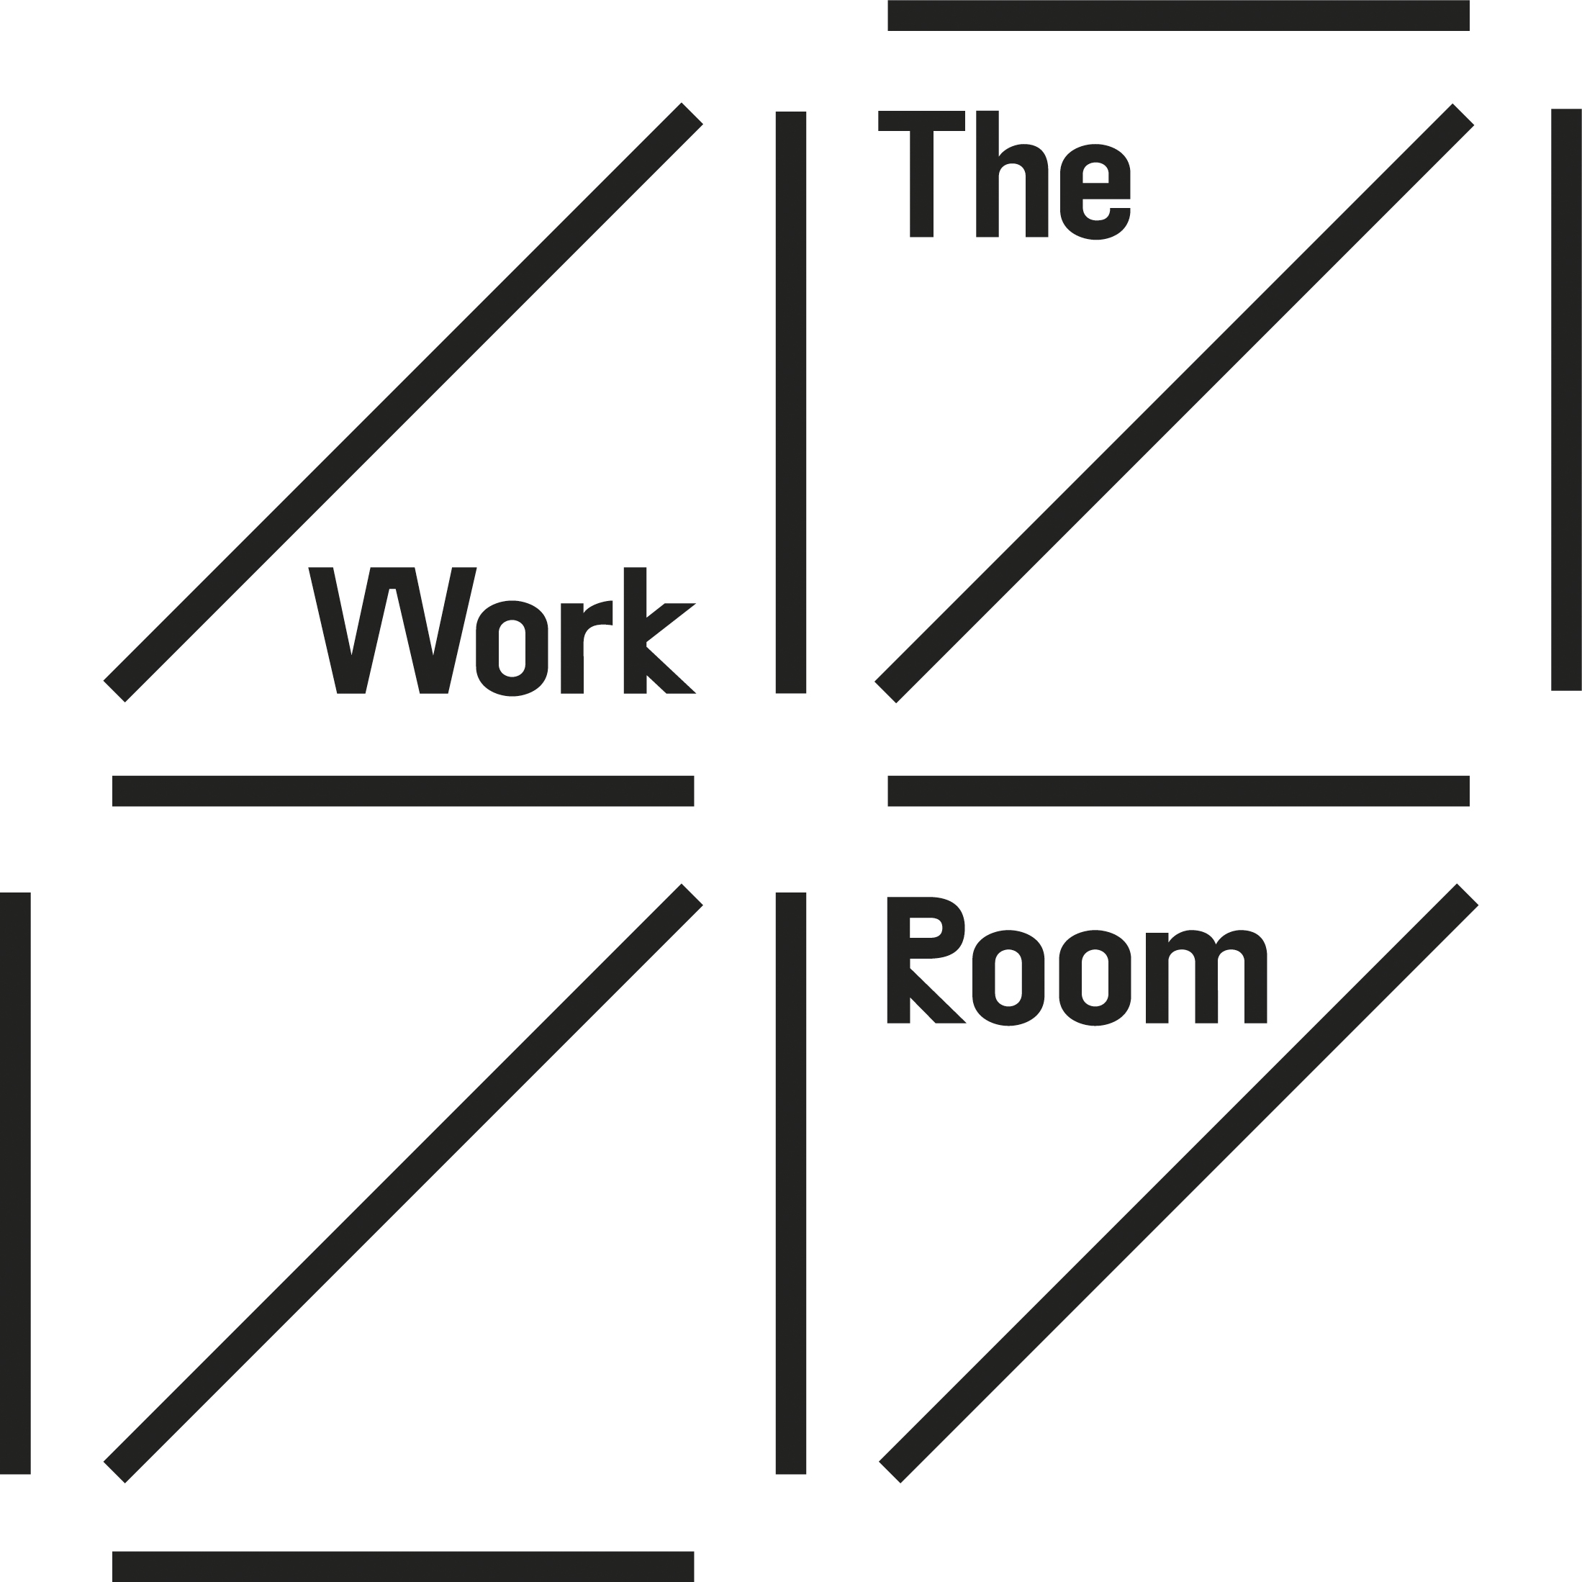
Artist Support Programme Facilitator
Part time role: equivalent of 3 days a week;
Salary £18,000 (£30,000 full time equivalent)
1 year fixed term

The Work Room is seeking an Artist Support Programme Facilitator, to join us in a new, one-year post, supported through Creative Scotland’s Cultural Recovery funds.

The role will lead on our work in artist support, engaging with our artist members to develop approaches to support our mission to support a sustainable environment for independent dance artists and empower artists in making pioneering dance for diverse contexts at home and internationally.

Over the past two years, we have been involved in many conversations about the urgent need to re-build and re-balance; for recovery to go hand-in-hand with re-imagining and dismantling the systemic inequalities within dance and the performing arts. Our membership of independent dance artists was hit exceptionally hard by the pandemic. Despite this, our memberships increased in number and we adapted our programme to support artists in different ways. This new role will help us better support this expanding community as we move forward.

As an organisation, we need to take breath, take stock and begin to rejuvenate our work and practice. We are seeking a creative, empathetic and agile person to work alongside our current team, as we move forward. The Artist Support Programme Facilitator will work closely with The Work Room’s small permanent staff team of Director (Anita Clark) and General Manager (Sara Johnstone).

This role is for someone with a dance practice and experience of organising, perhaps through self-producing their own artistic work, organising events or in supporting other artists in their work. The role is based on 3 days (21 hours) a week and there is flexibility in this with the potential for the total annual hours to be worked in a configuration that suits the post-holder enabling them to have concentrated periods to work on other projects.

About The Work Room:
The Work Room is an artist-led membership organisation, for those working in dance, movement and choreography in Scotland. Established by a group of independent dance artists in 2008, we are now a network of over 250 individuals. Our members create dance for different places including on stage and screen, in public spaces and galleries, and within communities. As an artist-led organisation, the priorities of our members inform our artistic programme and policies.

The Work Room supports dance artists through choreographic residencies, practice development and fostering an active community of artists. The values underpinning our work are generosity, inclusivity and experimentation. This model seeks to build a culture of responsibility and accountability across our membership, and feed grass roots leadership in the independent dance sector.

Who You Are:
We are keen to hear from you if you share our values and are:
- Keen to generously share your experience and skills to support our work with independent dance artists;
- Committed to working inclusively to ensure our work is accessible and relevant;
- Interested in experimentation and new ideas as we respond to current and future challenges.

To apply for this job, we are looking for you to demonstrate the following skills and experience:
- Experience as an artist with a dance/ choreographic practice;
- In-depth knowledge of dance in Scotland and understanding of a wider UK and international context;
- Strong organisational, administration and project management skills, including experience of managing budgets;
- Strong communication, active listening and inter-personal skills along with the ability to work collaboratively
- Ability to pay close attention to detail and maintain accuracy whilst handling a varied workload
- A reflective approach which values evaluation
- ICT and digital competencies.

Key responsibilities of the Artist Support Programme Facilitator will be:
- In dialogue with our members, identify needs, discuss ideas to inform our work in supporting a sustainable environment for independent dance artists;
- Conceive, develop and deliver projects and events in collaboration with our membership;
- Supporting The Work Room’s artist residency programme;
- Collaborate with The Work Room team in reporting, monitoring, evaluation and documentation of programmes;
- Continue to develop The Work Room’s commitment to equality, diversity & inclusion across our work, with a specific look at selection processes;
- To work in line with The Work Room’s vision and values, within allocated resources.

How to Apply:
Please send a letter of application along with your CV. In the letter please give examples that demonstrate how you meet the skills and experience, and the key responsibilities (as outlined above) for this role. Your letter should be no longer than 2 pages of A4.

If you have any questions about the role or would prefer this information in an alternative format, please contact us directly on hello@theworkroom.org.uk

The Work Room recognises there has been systemic exclusion within the arts sector and are striving to put equity at the heart of our practice and decision-making. We are committed to increasing the diversity of people working in dance and performance, and especially welcome applications from those who are significantly underrepresented in the sector.

The Work Room uses the social model of disability recognising that some people experience disabling barriers. We will interview all disabled applicants who meet the job criteria and we are committed to supporting any access requirements at interview and if appointed. Please indicate in your covering email if you considered yourself to be Disabled or identify as having a disability. Please note this information page will not be used to assess your application

All applicants must also complete an Equal Opportunities Monitoring Form. This is anonymous and will not be viewed alongside your application. It is for analysis purposes only.

Please email your letter of application and CV to: applications@theworkroom.org.uk

Deadline for applications: Monday 20 June 2022

All applicants will hear from us by Monday 27 June and with those shortlisted will be invited to an interview. We intend to hold interviews in person on Tuesday 5 July, in Glasgow and will cover necessary travel costs for those invited to attend. If for any reason, this would be difficult for you or there is anything you would need us to be aware of, please refer to this in your covering email.

Terms and conditions:
In this role you will be employed by The Work Room. It is a 1 year, fixed-term contract.

Salary: £18,000 (based on £30,000 pro rata)

Hours: 21 hours per week; flexible working is supported and we are open to this being an annualized hours contract, enabling the post holder to undertake concentrated periods of time on other projects.

Pension: The Work Room operates an auto-enrolment scheme through NEST and offers an employer’s contributions of 5% of salary

Annual leave: 20 days inclusive of public holidays

Location: our office base is within Tramway in Pollokshields, Glasgow. We are continuing with hybrid working with staff doing part of their work at home and partly in the office. While we are open to remote working, the appointed person will be required to work some days with colleagues in Glasgow on a regular basis.

The Work Room has two permanent members of staff: Anita Clark (Director) and Sara Johnstone (General Manager). You can read more about us, our board and membership on our website.

www.theworkroom.org.uk

