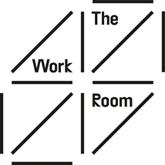
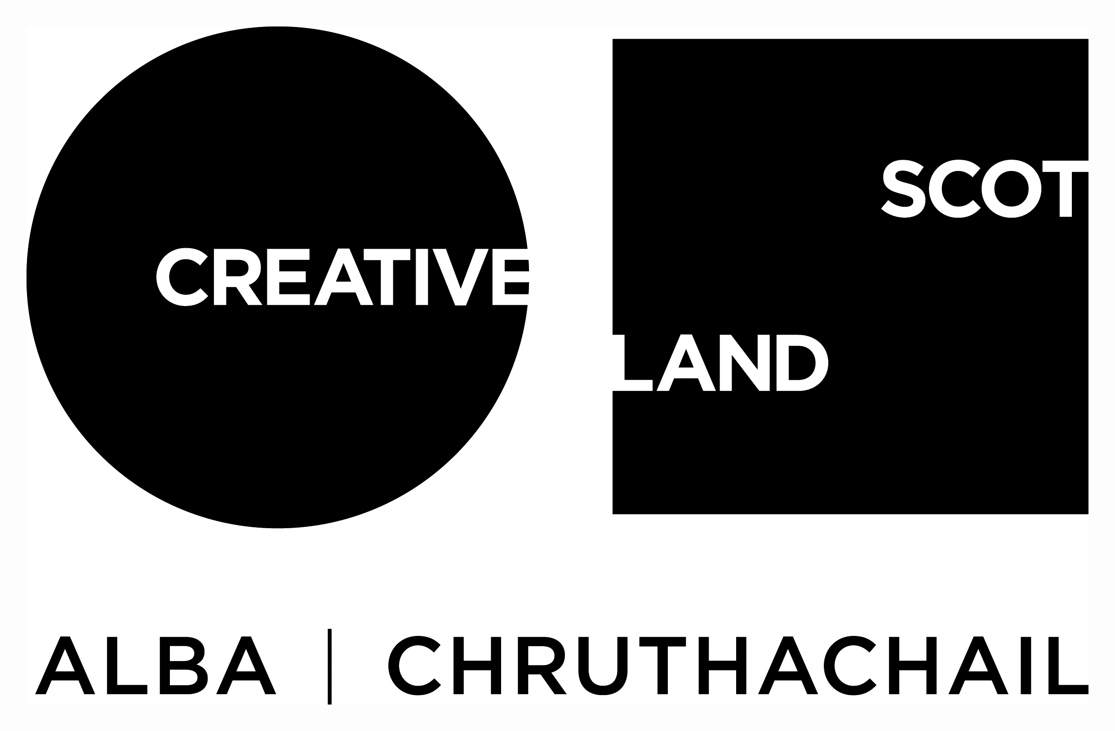
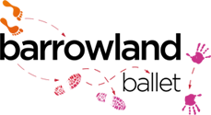

The Work Room & Barrowland Ballet:
Rosina Bonsu Bursaries for early career choreographers and dance artists

Application Form
Please read the Bursary Information Pack before completing this form. If you have any questions or would like support to complete this application form please email sara@theworkroom.org.uk.
There is no min or max word count for each section, as a guide aim for two to three paragraphs for each section. Please answer in your words, use links and images as you wish. The purpose of this application is to get a sense of where you are at now, what skills and knowledge you would like to develop and how this opportunity can support that.
Your Details
Name
Address
Contact Email
Contact Telephone Number
Please let us know of any access requirements you foresee participating in an interview & workshop.
Any costs such as travel incurred to undertake your interview will be reimbursed.
We are committed to interviewing any disabled applicant who meets the criteria for the Bursaries.
Do you identify as disabled & wish to be consider in this?

Eligibility
Please tick to confirm you are:
Aged between 18-24
Based in Scotland
Not in full time education (12 hours or more formal study per week)

About you
- Please tell us about your different experiences in education, employment and/ or volunteering that demonstrate the skills and aptitude we are seeking for the bursaries. You may wish to include here information on any barriers you have faced in following a career in dance.

- Please tell us what you would hope to achieve through the bursary:

- Please tells us about your experience and interest in initiating and setting up your own dance projects. This could be an example of a past project or something you are currently working on.

- Please provide us with a contact for a referee – someone who will be able to tell us about your dance experience.

Name
How this person knows you
Email
Telephone

- Please provide us with two pieces of film footage as part of your application. We are not concerned about the quality of the film of video / editing skills. We are looking to learn more about you and your practice, and see you move (if relevant)
You can either include links to your films here if you have uploaded to Vimeo or YouTube for example or you can WeTransfer to applications@theworkroom.org.uk

If you are going to transfer just write that in the box and we’ll look out for that.
 | Link | Password (if you have set one)
5a) A 3- 5 minute video telling us about your dance experience and approach to choreography
5b) A 3-5 minute video of your own choreography – this could be excepts from different pieces
5c) If relevant – a 3-5 minute video of you dancing

Thank you for your interest in this opportunity and telling us more about yourself. Please email your completed application form to applications@theworkroom.org.uk by Wednesday 16 February 2022. Please also complete the equalities monitoring form online here.
We aim to be back in touch with all applicants by Monday 28 February 2022. We have committed to provide verbal feedback to all applicants via phone or Zoom and you will be invited to a future The Work Room or Barrowland Ballet event.

