Making Video & Audio Applications: A practical guide
7 minute read
In recent years, The Work Room has been inviting members to apply for opportunities in different formats, including by making video or audio applications. But how do you put together a video or audio application and what makes a good one?
This blog sets out some hints and tips for preparing and recording a video or audio application.
Who might choose to make a video or audio application?
- You might make a video application if you are a BSL speaker, a more visual thinker or someone who struggles to communicate their ideas or projects in written words.
- You might choose to make an audio application if you are someone that finds looking at screens, reading or typing to be a barrier to making applications.
- Or perhaps the opportunity you are applying for specifies this method of application.
You don’t need to be someone with lots of skills or equipment in filmmaking or editing to make a video or audio application. It’s possible to make strong digital applications with just a mobile phone, webcam or powerpoint.

Video Applications
There are a number of different ways you might choose to approach a video application. The most common type of video application, is a ‘Talking Head’ style application, where the applicant speaks directly into the camera. Other approaches to video applications might incorporate more visual media such as images, drawings or film, such as a recorded slideshow or simple film, with text slides or spoken audio. These style applications are more common for ‘pitching’ projects.
Tip: For most applications a simple Talking Head style will be perfectly fine. Always check the call out to see if there any specifications around which approach to use before starting.
Five steps for putting together a talking head video or audio application:
- Prepare
- Practice
- Record
- Edit
- Upload

Step 1: Prepare
The key to a successful digital application, is preparation.

Before you begin filming, carefully read through the call out, application questions and selection criteria. Make a note of any time limits given to the length of your application- this will give you a good idea as to how much detail you need to give.

Make a plan: Answering all the questions and hitting all the points of the selection criteria can be a lot to remember while also trying to talk about your ideas, so it’s good to make a plan with clear notes, bullet points and a structure to follow while you’re talking.

Use the application questions as headings to structure your application. Allocate an approximate number of minutes to each question, based on which questions require the most information. Think about the parts of your project or practice you want to highlight in your application and list these as bullet points or subheadings under each question.

If you are a more visual thinker, drawing a mind map or having different coloured post it notes for each question, could be another approach to creating your plan.

Include in your plan any quotations, copy text or pieces of text you will read out in full, such as an artist statement, so everything is in one place.

Make sure the font is large enough that you can see it from a distance. You might want to print out your plan to cut into prompt cards, or stick pages onto the wall in front of you, while recording.

Tip: Remember to refer to the selection criteria as well as the questions. The question may ask you to talk about your project, but the selection criteria specifies that the panel are looking for projects which meet their programming objectives. In this case, when you talk about your project, you would also clearly identify how the project meets their programming objectives.

Step 2. Practice
Don’t expect yourself to be able to deliver your application in one take. Just like approaching any movement practice, warming up is important! It will likely take a few goes to get into the swing of speaking out loud, so it’s a good idea to do some practice runs before you hit record. If you will be talking in your application, you might also want to do a few quick vocal warm up exercises like tongue twisters or humming.

Practising each answer is a great way to edit your thinking and help you to become more clear, confident and concise in your articulation.

If you are working with tight time limits, it could be helpful to practice answering the question first with no time limitation and then slowly work your way down eg. 4 minutes > 3 minutes > 2 minutes. Using lists and bullet points are great ways to get information across in a short space of time.

Tip: Try taking a walk up and down your hall or around your home while answering the questions out loud, before sitting down to record, or warming with easy questions, like what you ate for lunch.

Step 3: Record

Find a quiet place with minimal distractions to setup your camera or phone, to record your application. You might use a tripod or laptop stand to get the audio recorder/camera at a good height for you.

While your application is primarily being assessed on its content, taking a few steps to ensure the quality of your recording is clear and easy to watch/listen to is important. For example, if you’re shooting a video application, don’t record with a window behind you, as most cameras will struggle to pick you out with strong backlighting (as below)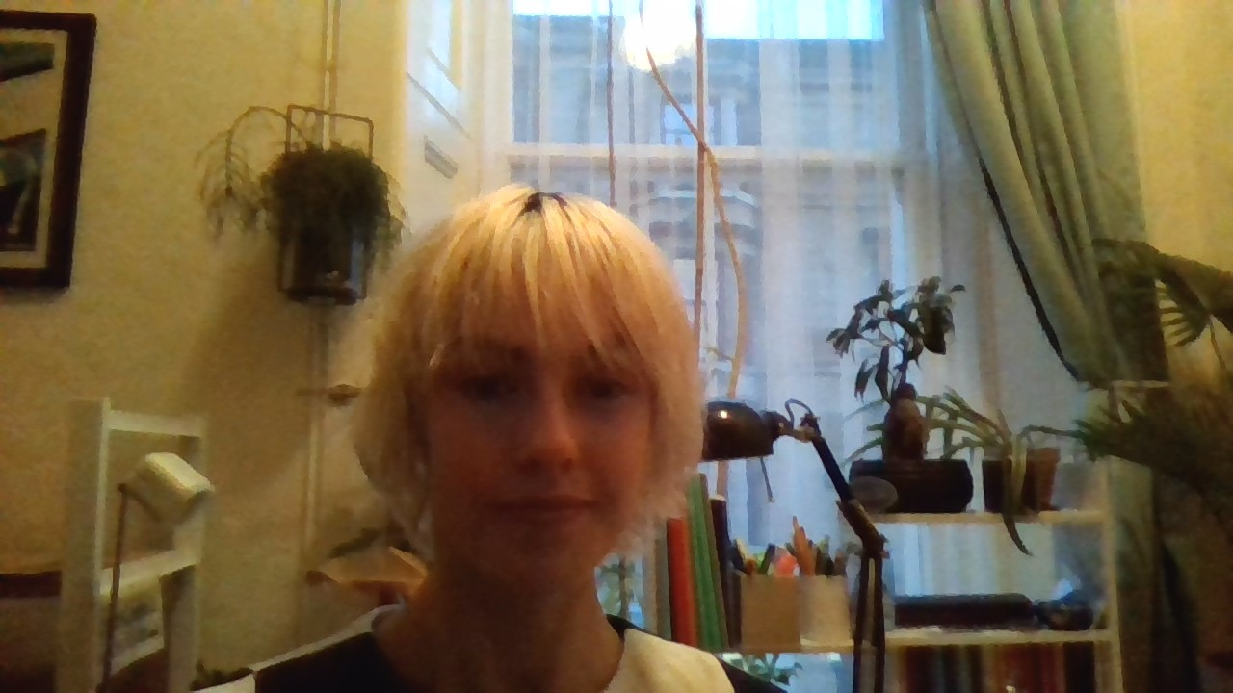

Facing a window or shooting in a place with good natural light will ensure the picture is clear and balanced. A plain wall or background (as below) can be good, where possible, especially for videos in BSL. Some webcams have a blur background feature you might choose to use if you don’t want the recipient to be able to see into your home.
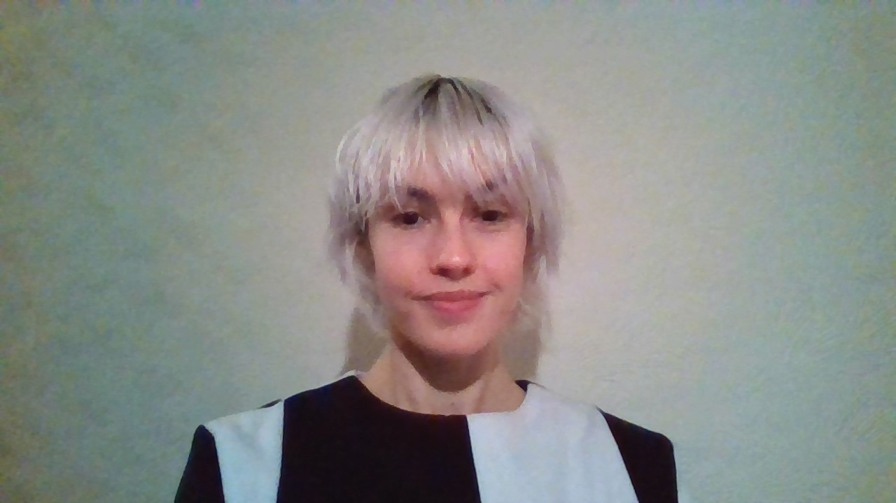

Do some test recordings and watch/listen back to them to make sure the audio is clear with minimal background noise and or/the picture is in focus and you are in frame. If the audio quality from your laptop microphone isn’t great, try plugging in a pair of smartphone earphones and using the mic to record.

Once you are happy with your setup, begin recording.

Start by giving all of the key information related to your application up front. This might include: your name, title of project, email address, what you are applying for, any specifications such as number of weeks of residency requested and any relevant dates. You could record this verbally or use a title screen.

Give yourself plenty of time to record multiple takes. For longer applications, you might want to split up your recordings into each question/heading in your plan. Or you might prefer to get into the flow and record the whole application in one go.

Tip: If you struggle to talk naturally into a camera/audio recorder, try having a friend or family member sit behind the camera to ask you the questions, so it feels more like a conversation.

Step 4: Edit
Take time to watch/listen through your recordings and select the best version(s). Asking someone to help you choose the best versions can be advantageous, but even taking a break between recording and editing can bring a fresh perspective.

You don’t need to have sophisticated editing skills or expensive software to put together a video or audio application. Many laptops and computers have basic video editing software such as iMovie, Garage Band, Audacity and Movie Maker, which can handle simple editing jobs such as trimming clips or creating one file from a number of clips.

If you have shot the whole thing in one go, it may not need any editing at all. Keep it simple.

Powerpoint can be useful for those less confident with video editing- use one slide to introduce the question followed by another with your audio or video answer. You can trim clips or audio in powerpoint, set timings for each slide and export in video formats.

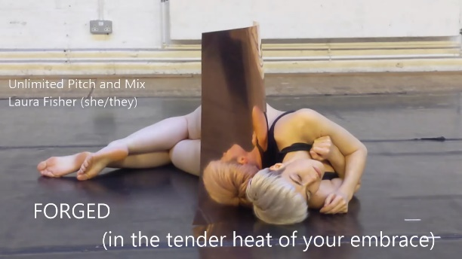
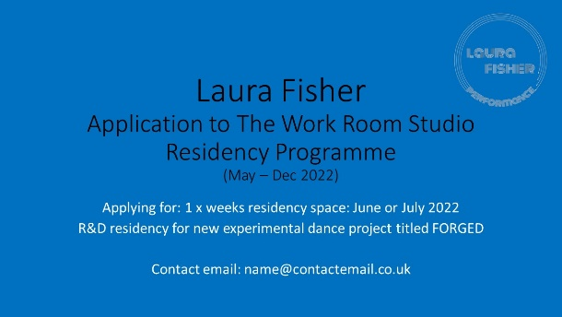
Tip: It can be useful to include a title screen, with basic info at the start and another at the end with your contact details, website etc. A title screen (examples below) can also be used as the video thumbnail, making it easy to find and identify the video application in your folders or once its upload.

Step 5: Upload
Export your file ready to upload. Common formats for video include MOV, MP4 or AVI, and for audio include MP3 or WAV.
Before uploading or submitting your application, watch or listen to the full video or audio file, to make sure everything is clear and there are no mistakes, glitches or unwanted surprises.

Most digital files will be too large to attach to emails, so most applications will ask for a link to your video or audio submission. Sites such as YouTube or Vimeo allow you to upload videos and Soundcloud, Mixcloud and YouTube can be options for audio uploads.

OneDrive, Google Drive and Dropbox are also all suitable for hosting and sharing links to audio or video files. Adjust privacy settings to be public or private. If your video is listed as 'Private', ensure you have enabled it so those with a link or password can view it.

Copy and paste your link into the application form or cover email, along with any other requested information. If your video settings requires a password, be sure to include the password in both the cover email and application form.

You are ready to submit your audio or video application! Remember, the content of your application is what is being assessed, not the style, so if in doubt, keep it simple. Good luck!

By Laura Fisher, for The Work Room. Date 11/01/2022

