The Work Room Artist Residency Programme

At the heart of The Work Room is our programme of supported, choreographic residencies. This programme supports experimentation and creative processes, from research through to production, according to the needs and requirements of each resident artist. The Work Room is committed to ensuring an expansive range of artists and artistic practices are visible and supported across our work.

Since the beginning of the pandemic, The Work Room has been in a process of reviewing, adapting and shifting across all aspects of our programme and artists’ support. We recognise that flexibility is key for many in the on-going challenging and changing circumstances. In response to our learning – particularly through our programme of Artists Research Bursaries - we are now experimenting with a more flexible approach to residencies.

The deadline of Monday 14 February is to consider residencies for the period May 2022 to December 2022.

About

The aim of our residency programme is to provide artists with time and space to deepen practice and/ or to research, develop and produce new work. Residencies have primarily taken place in The Work Room studio in Tramway and tend to be scheduled in week-long periods. As part of this call-out, we are also open to applications which propose alternative approaches. This may include working remotely, or in a space nearer to where you live, or over different durations of time. We want to be as flexible as possible within our resources and we encourage you to consider the most appropriate approach for you in developing your work at this time.

During the period May – December 2022, have 30 weeks of studio time and a budget of £20,000 to allocate. Each residency will have attached a bursary of £650 for each week (or equivalent) with the exception of any company who are in receipt of Regular Funding from Creative Scotland). To ensure a spread of residents, the maximum duration for any one residency is four weeks.

We recognise there are barriers to working in dance and that these challenges are felt more acutely by some people. We are committed to improving the accessibility of our residency opportunities for all our members and have an allocated access budget. This can be utilised towards additional support costs for example: interpretation, additional support needs, specific travel requirements or childcare.

Tramway and is level accessible from the street to the studio. You can find more information about the studio facilities including access information, equipment and dimensions here .

The studio is currently available Monday 12-5, Tuesday to Friday 10-5 and Saturdays 10-4. We encourage you to consider this is planning the approach to your residency time. While in residence, artists have exclusive access to the studio, green-room space and kitchen. Please see here for current guidance for activity within our studio.

The Work Room seeks to foster a community of artists and we encourage all our residents to consider how they will share the findings of their residency time with our wider membership. There is however, no obligation to offer a sharing or workshop as part of your residency. We work with you to facilitate any activities you may wish to offer and to ensure these comply with the current COVID-19 guidelines. We can also discuss options of holding workshops online or sharing work digitally.

How to Apply:

Applications can be made in writing, by downloading and completing an application form or by video or audio submission.
- Written applications should be submitted using no more than 2 pages of A4
- Video or audio applications should be no longer than 5 minutes long

Your application should include a response to:

- The idea or project that you wish to develop through a residency

- How you would approach the residency time, both artistically and practically

- Why this idea or project is important to you at this time, and how it will contribute to your wider practice and/or future plans?

- Please tell us about your current involvement in The Work Room and how you would propose to share your residency experience or findings with the wider membership

Additionally please include:
- How long would you like to be in residence and at what time? Please confirm if these dates are flexible fixed, ie in relation to a performance for example?

- Any access requirements you may have to support you to undertake the residency; this may include interpretation, Personal Assistance support, specific transport requirements and/ or childcare.

- If you are planning on working with other dance artists or collaborators during your residency, please tell us how this will be financed?
Alternatively, an application form with the relevant questions can be downloaded from our website. Completed applications should not exceed 3 pages.

Applications will be assessed on the quality of ideas presented, not on spelling, grammar or presentation. Please don’t worry about the quality of recording or the camera skills.

There is no need to include a CV or biography, but please do ensure that your profile on The Work Room’s members web-page is up-to-date as the panel will be asked to refer to this for information on your practice.

To submit your application please go to our website here and upload your application as either as Word or PDF document. If you are applying by video please paste a link to your video along with any password required in the Submissions portal.

Applications should be submitted through our website by Monday 14 February 2022.

All applicants will be notified of the decisions by 26 March 2022.

If require support in preparing or submitting an application, or would like to discuss the suitability of your proposal before applying, please contact us directly on hello@theworkroom.org.uk or by calling 07947 474 074 (Sara).

How to decisions will be made:

As an artists-led organisation, our selection processes are peer-assessed and all applications will be considered by a panel of 4-5 Work Rooms members. Members not applying for a residency at this time will be invited to put themselves forward to be part of this. We operate a conflict of interests process to manage inappropriate or undue influence on decision making.

Decisions will be informed by:
- The clarity of the proposal or idea presented;
- The approach that will be taken through the residency to explore this;
- The potential for this residency to contribute to the on-going development of an artistic practice.

Through our programme, we aim to achieve a balance of research & development residencies through to those that support production.

The final selection will also take into account our aim to support a wide a wide range of artists and practices, reflective of our membership.

Those unsuccessful will be given feedback and are welcome to apply to the next deadline.

Eligibility:

Applications for a residency should:
- Be a member of The Work Room;
- apply for only one residency during the residency period – however you can be involved in other members’ applications as collaborators and/ or performers.

Timeline:

Our deadline in 2022 is Monday 14 February for residencies for the period May to December 2022.

Applicants will be notified by 26 March 2022

All residencies are subject to programming availability and flexibility around dates assists with scheduling residency time. We understand that restrictions on activity within the studio could change significantly during this period and will work with all awarded artists to ensure that their residency time can be completed safely and in line with government restrictions.

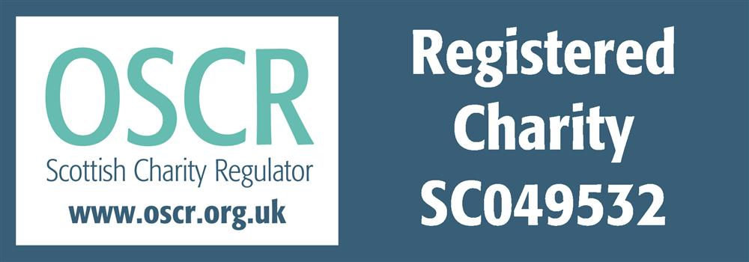
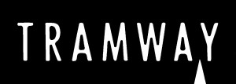

The Work Room (Dance) is a limited company by guarantee with charitable status, registered in Scotland with Company No SC343929 and
registered Scottish Charity No SC049532 with its registered office at
Tramway, 25 Albert Drive, Glasgow G41 2PE

