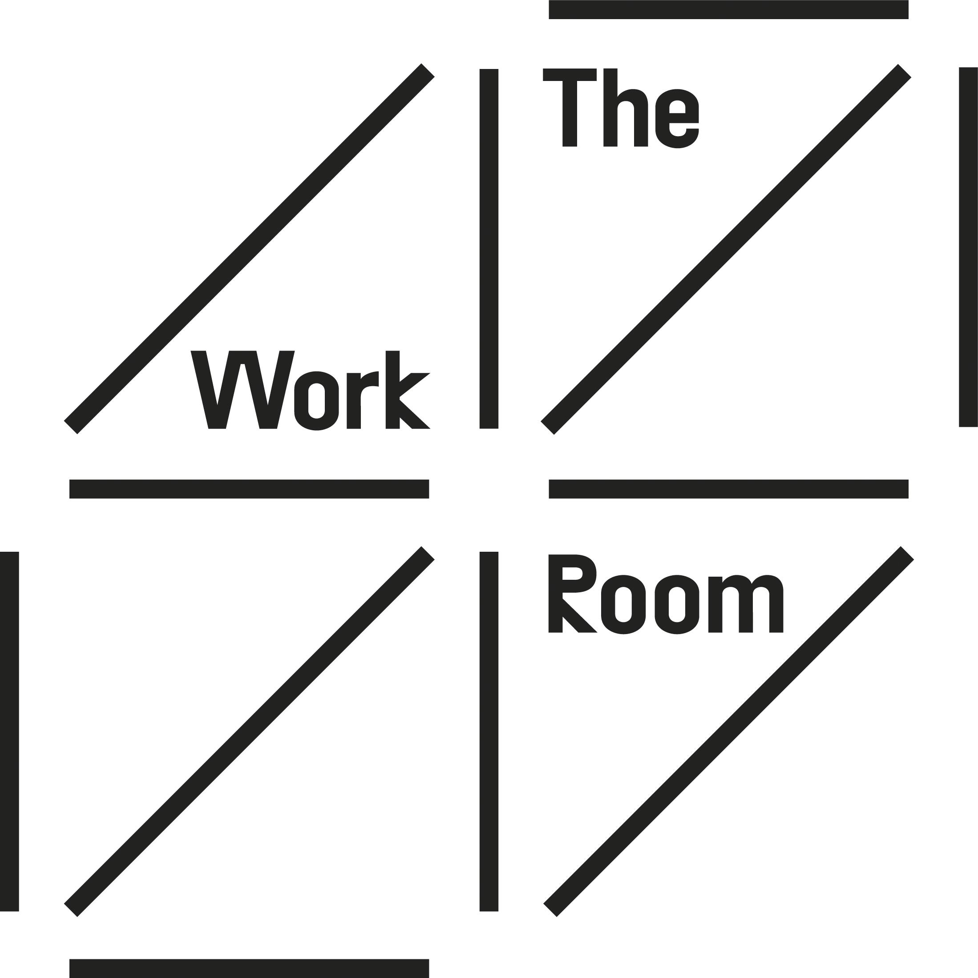

The Work Room is seeking new Board Trustees

We are seeking people to join our board in 2021, to work alongside our existing board trustees in supporting The Work Room in its mission to empower artists in making pioneering dance for diverse contexts at home and internationally.

About The Work Room:
The Work Room is an artist-led membership organisation, for those working in dance, movement and choreography in Scotland. Established by a group of independent dance artists in 2008, we are now a network of over 200 individuals. Our members create dance for different places including on stage and screen, in public spaces and galleries, and within communities.

As an artist-led organisation, the priorities of our members inform our artistic programme and policies. This model provides a distinctive leadership approach for the independent dance sector in Scotland.

The Work Room supports dance artists through choreographic residencies, practice development and fostering an active community of artists. The values underpinning our work are generosity, inclusivity and experimentation.
As with many arts organisations, the past year has presented significant challenges. With theatres closed and no live performances, The Work Room's mission to support a sustainable environment for independent dance artists has been brought into sharp focus. Our response has sought to provide both practical support and advocacy for independent dance artists through this crisis. Looking to the future, our ability to be agile, generous and work with empathy, will be critical as we play a role in the recovery of the performing arts. You can read more about our work over the past year here

Who we are looking for?

As a registered charity, The Work Room’s board is the charity trustees with responsibility for governing the organisation. They are responsible for the legal, financial and organisational overview of The Work Room, and the strategy that underpins the membership led structure. The board includes artists who are members of The Work Room along with people who bring their skills and experience from other areas to support our work.

We’d love to hear from you if you share our values and are:

- Keen to generously share your experience and skills to support our work with independent dance artists;
- Committed to working inclusively to ensure our work is accessible and relevant;
- Interested in experimentation and new ideas as we respond to current and future challenges.

The Work Room recognises systemic exclusion within the arts sector and we are striving to put equity and inclusion at the heart of our work as we work towards an Anti-Racism practice. In supporting this, we want the board to better reflect the diversity of our membership and particularly welcome applications from:
- People of colour and those who are ethnically diverse
- D/deaf, disabled or neurodivergent people
- LGBTQI+ people
- People based outside the central belt of Scotland

Some of the skills and knowledge that would be useful include:
- Organisational development and HR;
- Experience and knowledge in dance, across different styles & genres;
- Environment and sustainability;
- Finance and fund-raising;
- Digital working

You may have developed these interests through working for a small or large organisation, through working for yourself, through volunteering or life experience.

You don’t need to have prior experience on a board and we will provide a full induction and help you understand the role and responsibilities of being a charity trustee. Board trustees serve in a voluntary capacity but we cover any related expenses and we are committed to putting in place any access support required to enable full participation in board meetings. This could include childcare costs, providing BSL interpretation for meetings and/ or providing information in different formats.

What the role involves:

The role of the Board trustees is to support the work of The Work Room and provide leadership and strategic governance, in line with the core purpose and policies of the company. The Work Room is a charity, and our board of trustees are guided by the guidance and good practice provided by the Office of Scottish Charity Regulator. OSCR (Office of the Scottish Charity Regulator)

The board usually meets four times a year as well as participating in the AGM (Annual General Meeting) open of all members. In addition to this, trustees may get involved in events, training or on sub-committees. A key aspect of the role is to build a collegiate working relationship with The Work Room staff team and other board members contributing to collective and considered decision making.

We consider key qualities of board trustees to include:
- Asking questions and participating in discussions leading to collective decision making;
- The ability to act discreetly and to respect confidentiality;
- A genuine interest in and commitment to The Work Room’s work, dance and artists;
- A willingness to learn about the wider context in which The Work Room is situated.

Next steps:
If you are interested in submitting an expression of interest to join our Board trustees, you are invited to provide a response to the questions below in writing or another format, such as video or audio message.

We suggest that a written response to the questions should be around 1 page of A4 and a video/ audio response should be around 5 minutes long.

- Please tell us about your interest in joining The Work Room as a trustee and what you feel you could bring to the board;
- Please tell us a bit about yourself including your skills and experience –particularly if this relates to any of the areas we have referenced on page 2;
- Please tell us what you would hope to get from the experience of being a trustee of The Work Room;
- If you wish, please tell us if you identify with any of the protected characteristics or lived experience currently under-represented and identified on page 2.

Please include your name and contact details along with information on any communication or access requirements you would like us to be aware of. You can also include a link to a website or other source of information that you would like us to be aware of. Expressions of interest should be emailed to: board@theworkroom.org.uk

Deadline: 5 July 2021

We are being supported in this board recruitment process by Sophie Amono, an independent equalities, diversity, and inclusion consultant. Sophie is working with us on the recruitment and will continue to support the Board appointment, induction and strategy from a diversity and inclusion perspective. Sophie’s experience includes sitting on the BIMA Inclusion & Diversity Council, Creative Scotland Equalities, Diversity, and Inclusion Advisory Group, and British Council Arts New Narratives Advisory Board. She is on hand to discuss the opportunity with any underrepresented communities and she can be reached at sophie@idostuffs.co.uk.

Should you have any questions about the process or require assistance in applying, please contact Anita Clark, The Work Room’s Director at anita@theworkroom.org.uk
You can also contact Anita if you would like to have an informal conversation about what the role involves and she can put you in touch with one of our current board trustees to talk to them about the role.

All applications will be treated in confidence and read only by our Board trustees, Anita and Sophie. We will acknowledge applications within a week of the deadline and respond with an Equalities Monitoring form to complete along with details of the next steps. Shortlisted applicants will be invited to meet with some people involved in The Work Room (including current trustees, our staff team and artists members) and to observe a board meeting. There will then be a special members meeting in September to consider and adopt recommendations for board trustees.

Timeline:
June | Open sessions for anyone interested in finding out more
5 July | Deadline for application
July/ August | Meetings with prospective board trustees
September | Special members meeting to consider recommendations for board trustees
October – December | Induction process with staff team

Finding our more:
We will be holding a number of open sessions, where there is the opportunity chat to existing Board trustees about The Work Room and the role. These will be held on Zoom and we can arrange captioning, BSL interpreter or other access requirements.

- Friday 11 June: 1 – 2pm
- Tuesday 15 June: 10.30 - 11.30am
- Wednesday 23 June: 6-7pm

Please contact board@theworkroom.org.uk for details on joining any of these sessions.

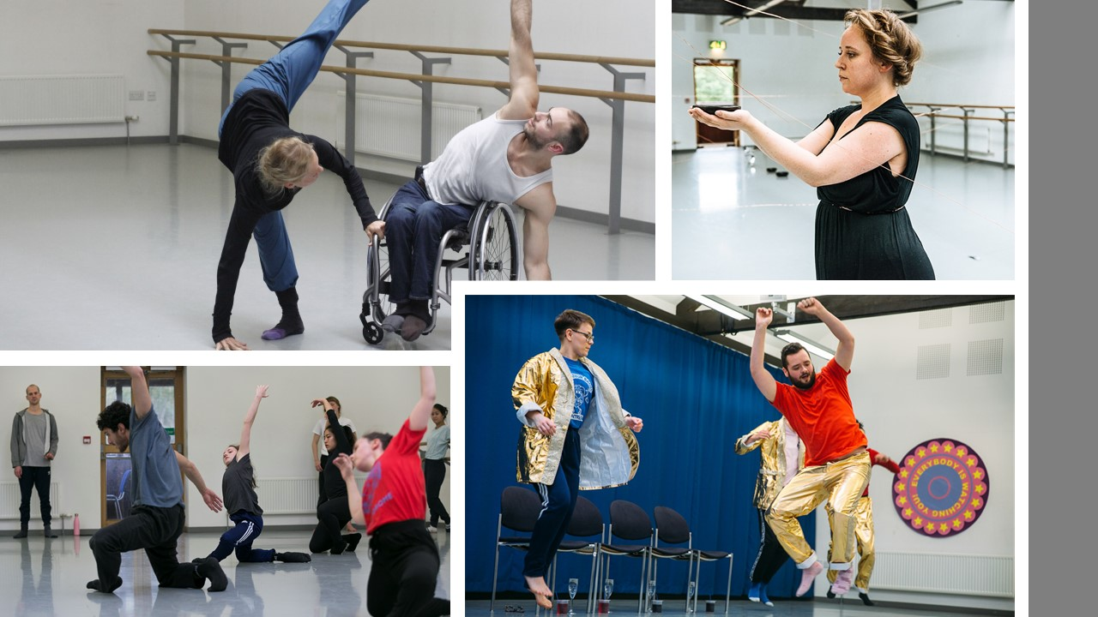
Image credits clockwise from top left - Eve Mutso & Joel Brown photo by Susan Hay; Amy Rosa photo by Brian Hartley; Pro Class led by Francesco Ferrari photo by Eoin Carey, Aby Watson & Craig Manson, photo by Jassy Earl.

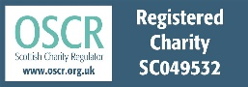
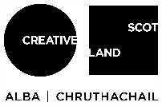
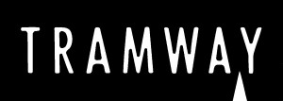
The Work Room (Dance) is limited company by guarantee with charitable status, registered in Scotland with Company No SC343929 and registered Scottish Charity No SC049532 with its registered office at
Tramway, 25 Albert Drive, Glasgow G41 2PE

