The Work Room Core Studio Residency Programme

At the heart of The Work Room is our programme of supported, choreographic residencies. This programme supports experimentation and creative processes, from research through to production, according to the needs and requirements of each resident artist. Since the beginning of the pandemic we have been through the processes of cancelling, rescheduling and shifting that so many artists and organisations have also faced in this past year. We have made some updates to this call out following learning from that period and to support a flexible approach to studio time.

If a studio residency doesn’t feel accessible to you at this time, we are supporting an additional programme of Artists Research Bursaries. The Work Room is committed to ensuring an expansive range of artists and artistic practices are visible and supported across our work.

About

Residencies primarily take place in The Work Room studio in Tramway. They provide artists with time and space to research, develop and produce new work. The deadline of Monday 7 June is to consider residencies for the period August 2021 to March 2022. Residencies tend to be awarded in week-long periods but we can be flexible in this to meet members’ needs. To ensure a spread of residents, four weeks is the maximum duration of any one residency.

Tramway and is level accessible from the street to the studio. You can find more information about the studio facilities including access information, equipment and dimensions here .

With the gradual easing of restrictions we are operating within Tramway’s opening hours which is currently Tuesday to Saturday, 10 – 4pm. We encourage you to consider this is planning the approach to residencies. While in residence, artists have exclusive access to the studio, green-room space and kitchen. Please see here for current guidance for activity within our studio.

The Work Room seeks to foster a community of artists and we encourage all our residents to consider how they will share the findings of their residency time with our wider membership. There is however, no obligation to offer a sharing or workshop as part of your residency. We work with you to facilitate any activities you may wish to offer and to ensure these comply with the current COVID-19 guidelines. We can also discuss options of holding workshops online or sharing work digitally.

A weekly bursary of £600 shall be made available to members awarded a residency (with the exception of any company who are in receipt of Regular Funding from Creative Scotland). We are committed to improving the accessibility of our residency opportunities for all our members. We have an allocated access budget that can be utilised towards support costs including interpretation, additional support needs, specific travel requirements and childcare, for example.

How to Apply:

Applications can be made in writing, by downloading and completing an application form or by video or audio submission.
- Written applications should be submitted using no more than 2 pages of A4
- Video or audio applications should be no longer than 5 minutes long

Your application should include a response to:

- The idea or project that you wish to develop through a residency

- Why this idea or project is important to you and why now is the right time to work on it?

- What you hope to achieve or discover by the end of your time in residence?

- How working on this idea or project at this time will contribute to your wider practice and future plans?

- Please tell us about your current involvement in The Work Room and how you would propose to share your residency experience or findings with the wider membership?

Additionally please include:
- How long would you like to be in residence and at what time? Please confirm if these dates are flexible fixed, ie in relation to a performance for example?
- Any access requirements you may have to support you to undertake the residency; this may include interpretation, Personal Assistance support, specific transport requirements and/ or childcare.
- If you are planning on working with other dance artists or collaborators during your residency, please tell us how this will be financed?
Alternatively, an application form with the relevant questions can be downloaded from our website. Completed applications should not exceed 3 pages.

Applications will be assessed on the quality of ideas presented, not on spelling, grammar or presentation. Please don’t worry about the quality of recording or the camera skills.

There is no need to include a CV or biography, but please do ensure that your profile on The Work Room’s members web-page is up-to-date as the panel will be asked to refer to this for information on your practice.

To submit your application please go to our website here and upload your application as either as Word or PDF document. If you are applying by video please paste a link to your video along with any password required in the Submissions portal.

Applications should be submitted through our website by Monday 7 June 2021.

All applicants will be notified of the decisions by Monday 19 July 2021

If require support in preparing or submitting an application, please contact us directly on hello@theworkroom.org.uk or by calling 07947 474 074 (Sara).

How to decisions will be made:

As an artists-led organisation, our selection processes are peer-assessed and all applications will be considered by a panel of 4-5 Work Rooms members. Members not applying for a residency at this time will be invited to put themselves forward to be part of this. We operate a conflict of interests process to manage inappropriate or undue influence on decision making.

Decisions will be informed by:
- The clarity of the proposal or idea presented;
- The approach that will be taken through the residency to explore this;
- The potential for this residency to contribute to the on-going development of an artistic practice.

Through our programme, we aim to achieve a balance of research & development residencies through to those that support production.

The final selection will also take into account:
- The amount of previous residency time awarded to the artist;
- Our aim to support a wide a wide range of artists and practices; reflective of our membership.

Those unsuccessful will be given feedback and are welcome to apply to the next deadline.

Eligibility:

Applications for a residency should:
- Be a members of The Work Room;
- Not be applying for the Artists Research Bursary programme 2021/ 22;
- apply for only one residency during the residency period – however you can be involved in other members’ applications as collaborators and/ or performers.

Timeline:

Our deadline in 2021 is Monday 7 June for residencies for the period August to March 2022.

Applicants will be notified by 19 July 2021.

All residencies are subject to programming availability and flexibility around dates assists with scheduling residency time. We understand that restrictions on activity within the studio could change significantly during this period and will work with all awarded artists to ensure that their residency time can be completed safely and in line with government restrictions.

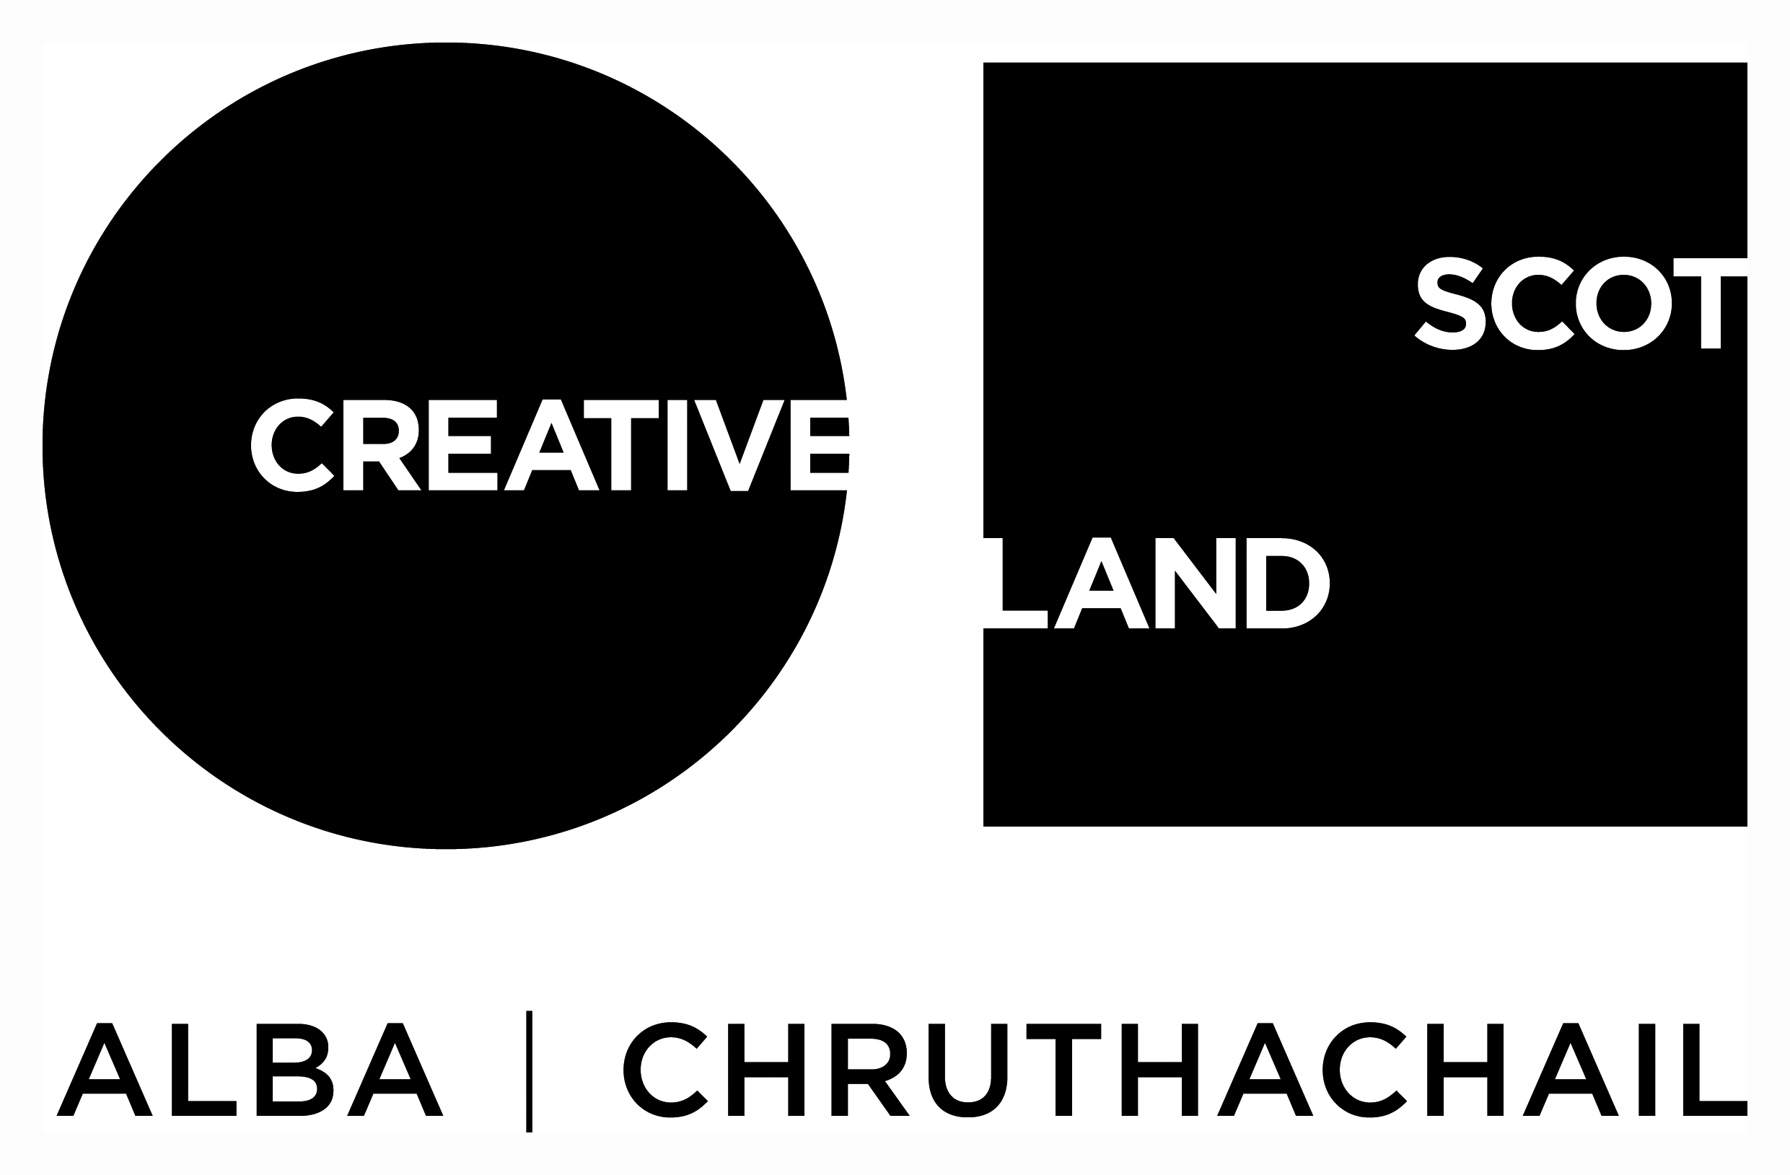
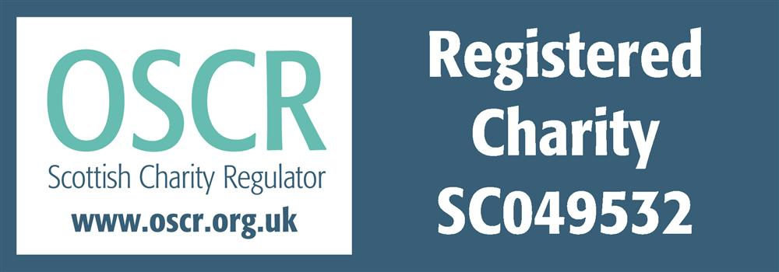
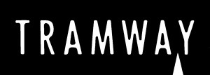

The Work Room (Dance) is a limited company by guarantee with charitable status, registered in Scotland with Company No SC343929 and
registered Scottish Charity No SC049532 with its registered office at
Tramway, 25 Albert Drive, Glasgow G41 2PE

