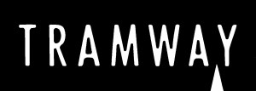
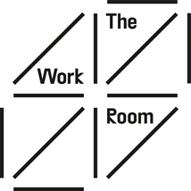

The Work Room & Tramway Early Career Dance Artist
Weston Jerwood Creative Bursaries

Application Form
Please read the job pack before completing this form. If you have any questions or would like support to complete this application form please email sara@theworkroom.org.uk.
There is no min or max word count for each section, as a guide aim for two to three paragraphs for each section. Please answer in your words, use links and images as you wish. The purpose of this application is to get a sense of where you are at now, what skills and knowledge you would like to develop and how this opportunity can support that.
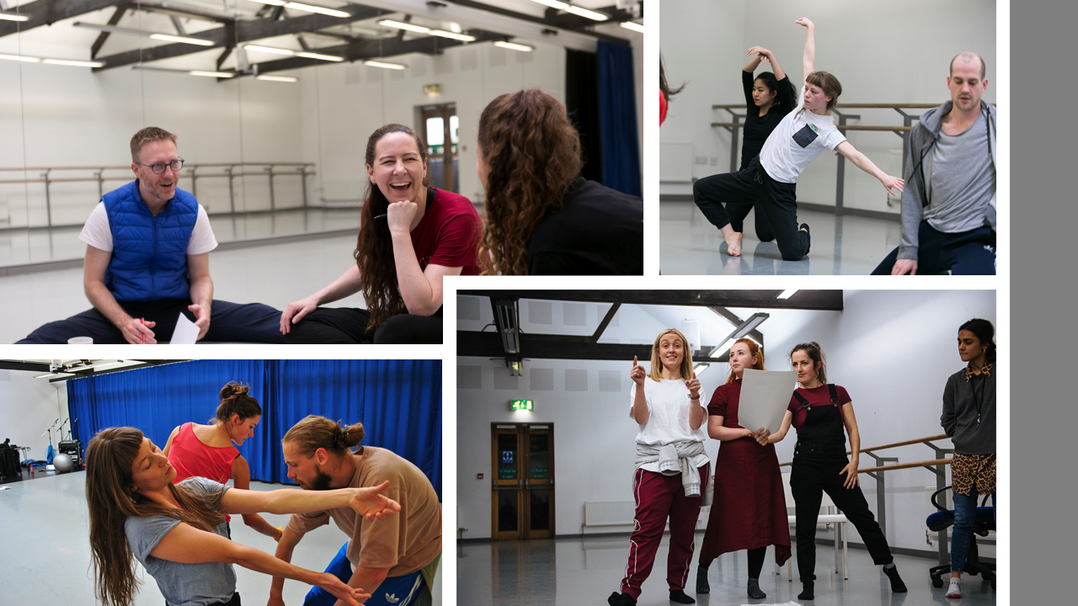
Images, clockwise from top left: International Artist Exchange in TWR studio, photo by Eoin Carey; Professional Contemporary Class in TWR studio, photo by Eoin Carey, Joan Cleville Residency, photo by Vicky Wilson, Members presenting in TWR studio, photo by Brian Hartley.

Your Details
Name
Address
Contact Email
Contact Telephone Number
At present we are not sure if interviews will take place in Tramway or via an online meeting platform such as Zoom. Please let us know of any access requirements you foresee in either undertaking a digital or in person interview. This may include BSL interpretation or access to WiFi and a laptop. Any costs such as travel incurred to undertake your interview will be reimbursed.
About you
- Please tell us about your different experiences in education, employment and/ or volunteering that demonstrate the skills we are looking for in this post (as outlined in the ‘Who you are’ section on page 2 of the job pack):

- Please tell us why you are interested in this role and what you hope to achieve or discover during the 12 months:

- Please tells us about your experience and interest in initiating and setting up your own dance projects. This could be an example of a past project or your ideas for something in the future.

- Please provide us with a contact for a referee – someone who will be able to tell us about your dance experience.

Name
How this person knows you
Email
Telephone

- Please provide us with two pieces of film footage as part of your application. We are not concerned about the quality of the film of video / editing skills. We are looking to learn more about you and see you move.
You can either include links to your films here if you have uploaded to Vimeo or YouTube for example or you can WeTransfer to sara/anita@theworkroom.org.uk.
If you are going to transfer just write that in the box and we’ll look out for that.
 | Link | Password (if you have set one)
6a) A 3- 5 minute video telling us about your dance experience and approach to choreography
6b) A 5 minute video of your own choreography – this could be excerpts from different pieces

Thank you for your interest in this opportunity and telling us more about yourself. Please email your completed application form & monitoring form to applications@theworkroom.org.uk by 7 December 2020.
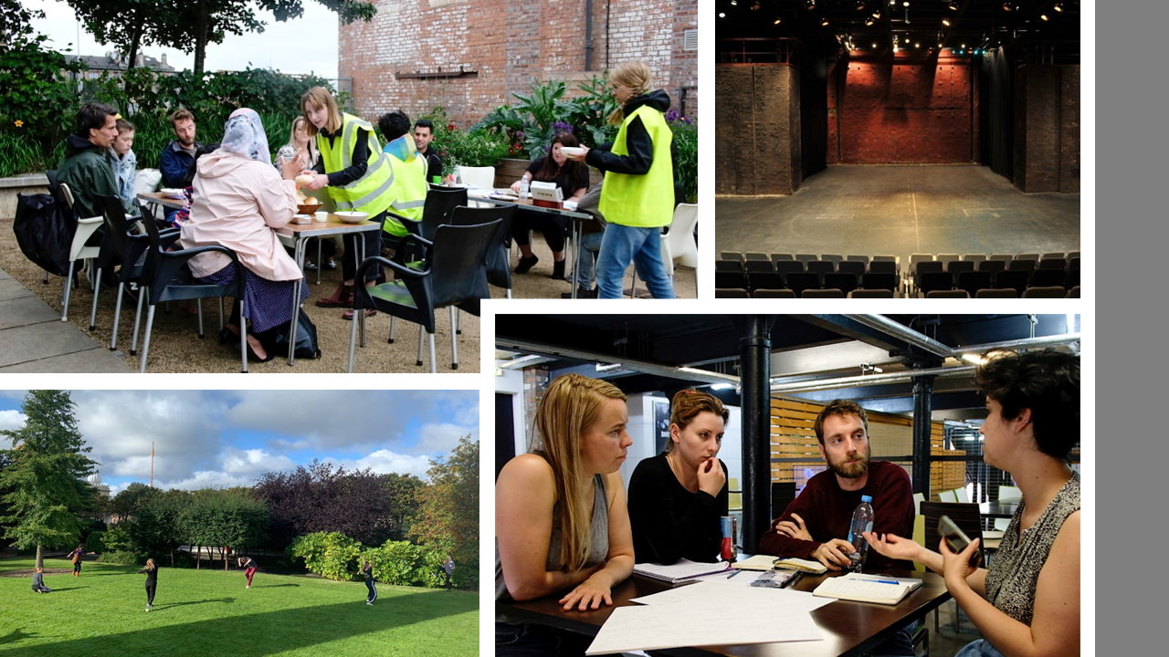
We aim to be back in touch with all applicants by 18 December 2020. We have committed to provide verbal feedback to all applicants via phone or Zoom and you will be invited to a future Tramway or The Work Room event. Regardless of the outcome of this application we want this to be the start of your connection to Tramway & The Work Room.
Images, clockwise from top left: Theatre Senza Residency in Tramway Gardens, photo by Giulia Candussi , Tramway main Theatre space T1, photo courtesy of Glasgow Life, Professional Class in Hidden Gardens, photo courtesy of Barrowland Ballet, Theatre Senza meeting in Tramway, photo by Giulia Candussi

