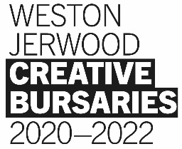
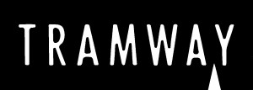
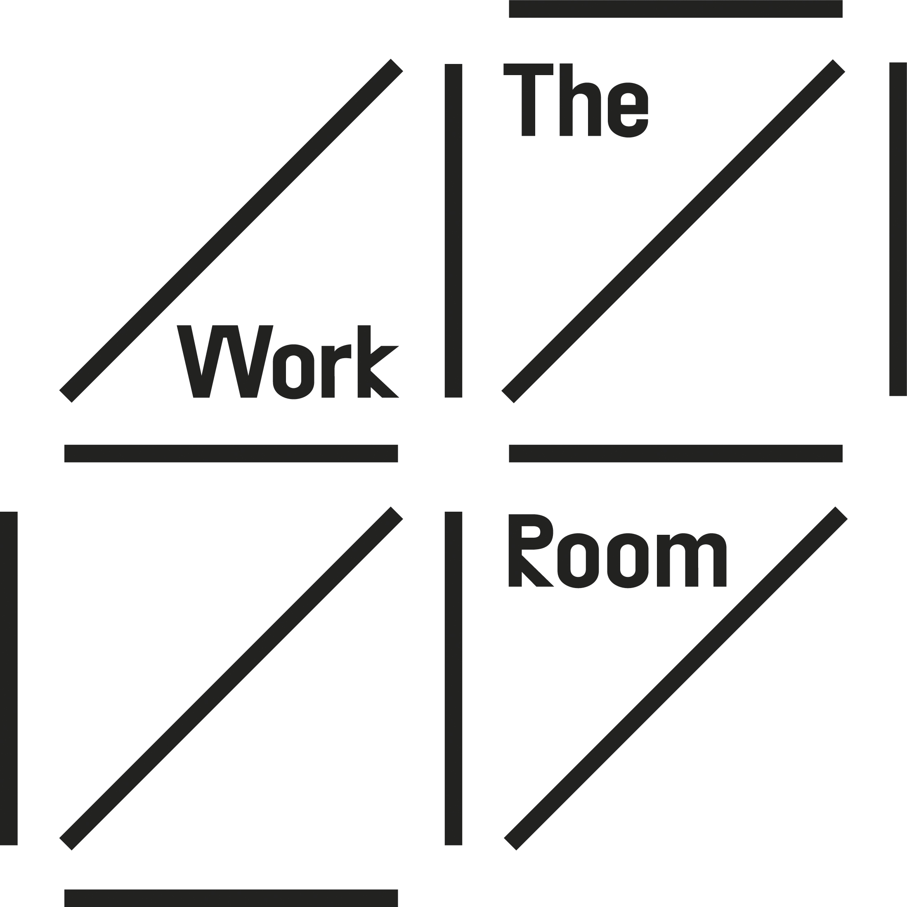

Early Career Dance Artist
(Salary £21,000 - 1 year fixed term; based in Glasgow)

The Work Room & Tramway are seeking a dance artist at an early stage of their career, to join us to work with both organisations. This new, one-year post is part of the Weston Jerwood Creative Bursaries programme which is seeking to make the arts a fairer and more inclusive place to work. For this reason, this post is designed to support the career progression of someone from a lower socio-economic background. There is more information on the programme in pages 6 & 7 and what is meant by ‘lower socio-economic background’ can be found here.

In this role, you will work across both organisations and be supported by us to:
- Develop your own choreographic skills and creative practice;
- Work as part of The Work Room & Tramway teams to develop your understanding and experience in dance management, producing and programming;

We will work with the person appointed to put in place a work-plan and schedule, responding to your interests and ambitions. Over the course of the year, we anticipate this include time spent:
- On your dance training and expanding your skills through going to class, participating in workshops, shadowing other choreographers and seeing dance performances;
- Researching and developing your own creative projects;
- With The Work Room team, helping to organise the programme and member events;
- With the Tramway performance team, helping to organise performances and projects;
- Being active within the wider dance sector through attending events and meeting with other organisations to build your network.

Additionally, through the Weston Creative Bursaries programme, you will participate in a professional development programme. You will get an outside mentor and be part of a UK wide network of similar posts. There is more information on this here.

The Work Room and Tramway recognise that there are inequalities across society and many barriers to working in the arts. We are committed to addressing these and want dance in Scotland to truly reflect the diversity of our communities.

Who You Are:

We are keen to hear from you if:
- You are a dance artist/ choreographer at an early stage of career based in Scotland;
- You have undertaken your dance training full-time at college/ university or university or equally through more informal roots. We recognise that not everyone has access to formal education programmes because they are not available in all dance styles and not accessible for many people;
- You relish experimenting within whatever dance genres you work in. This may include Hip-hop or street dance styles; South Asian dance such as Bharatanatyam or Kathak; dance from the African and Caribbean diaspora; contemporary or Scottish traditional dances – or many other dance styles and genres;
- You have experience and interest in initiating and setting up your own creative projects;

To apply for this job, we are looking for you to demonstrate:
- Your passion for dance and an openness to learning about different artistic forms and expressions;
- You have faced barriers to furthering your career in dance because of your experiences and socio-economic background. (e.g. maybe you haven’t been able to afford to access the dance training you would have liked, or been able to go to performances or doing other jobs has prevented you from spending time on dance);
- You have creative ideas and, with the right support, are able take these forward;
- You have skills in communicating your ideas and working with others in a team;
- You are organised and able to manage different demands;
- ICT competencies with some skills in Microsoft Word & Excel and social media.

This role is designed for someone towards the beginning of their career with between 2 - 5 years of experience since leaving school. This experience could include further education, employment or volunteering and may have included breaks through different life experiences. We recognise that you may have faced barriers to following a career in dance previously and we welcome applications from those who may have taken an unconventional route.

Additionally, to apply for this post, you must:
- have the legal right to work in the UK;
- not be in full time education (12 hours or more formal study a week).

How to Apply:
- Submit a 3-5 minute video telling us about your dance experience and approach to choreography;
- A 3-5 minute video of your own choreography – this could be excerpts from different pieces;
- Complete the application form including contact details for a referee – someone who will be able to tell us about your dance experience.

Please don’t worry about the quality of recording or the camera skills. We are interested in what you have to say, rather than the technical capacity. If you have any questions about the role, require any assistance in submitting your application including making or sending the videos or would prefer an alternative format, please contact us directly on sara@theworkroom.org.uk

The Work Room & Tramway recognises there has been systemic exclusion within the arts sector and are striving to put equity at the heart of our decision making. We are committed to increasing the diversity of people working in dance and performance, and especially welcome applications from those who identify as having characteristics currently under-represented. This includes black people and people of colour, disabled people, individuals identifying as LGBTQI, those with parental responsibilities and people from working-class backgrounds. There is recognition that Black artists and artists of colour have been historically under-represented in Tramway’s programme and they are working to change this.

The Work Room & Tramway use the social model of disability recognising that some people experience disabling barriers. We will interview all disabled applicants who meet the job criteria and are committed to supporting any access requirements at interview and if appointed.

All applicants must also submit an Equal Opportunities Monitoring Form. This is anonymous and will not be viewed alongside your application. It is for analysis purposes only.

Please email the completed application form along with links to your videos to:
applications@theworkroom.org.uk

Deadline for applications: Monday 7 December:

All applicants will hear from us by Friday 18 December, with those shortlisted invited to interview week 7 January 2021. At this stage we don’t know is it will be possible to host interviews in person at Tramway or whether we will do these virtually. We will cover travel or other expenses involved in attending and participating in an interview.

Terms and conditions of the role:
This is a full-time job for 1 year. You will be employed by The Work Room and work across both organisations.

Salary: £21,000, 1 year fixed-term contract

Pension: The Work Room operates an auto-enrolment scheme through NEST and currently offers statutory contributions

Hours: 35 hours per week; flexible working is supported and may be required with occasional evening and weekend work. Some travel may also be required. No over time is paid but time off in lieu is offered.

Annual leave: 33 days inclusive of public holidays

Location: Tramway
(currently, due to the Covid-19 pandemic, our teams are working primarily from home using remote working tools. You will be provided with a laptop computer and any other equipment required to make this possible)

About The Work Room
The Work Room is a membership organisation, committed to creating a sustainable environment for independent artists working in dance and choreography in Scotland. Our mission is to empower artists to lead in their practice, enabling them to make high quality, intelligent, pioneering contemporary dance for diverse contexts at home and internationally.

The Work Room was established by a group of independent dance artists in 2008. As a membership organisation, the priorities of our members continue to inform the organisation’s artistic programme and policies. We aim to foster a community of artists, encouraging our members to be active in the independent dance sector in Scotland. Our strength is in over 180 individuals working in dance; a powerful network of connections, experience and skills. These are artists at different stages of their careers, creating dance for many different contexts including stage, screen, public spaces, galleries and with communities.

The active involvement of artists within our activities and working groups enables a strong culture of grassroots leadership within our organisation. We relish our responsibility to ensure that an expansive range of artists and artistic practices are visible and supported. We strongly believe that dance resonates and is relevant for more audiences when it is engaging with and reflecting the diversity of our communities.

The Work Room has two members of staff: Anita Clark (Director) and Sara Johnstone (Studio & Membership Manager). You can read more about us here.

www.theworkroom.org.uk
About Tramway:
Tramway is an international art-space which commissions, produces and presents contemporary arts projects. Its offering crosses performance and visual arts. This role will cover the performance aspects of the programme which has a strong dance and Live Art focus as well as a participatory strand that speaks to these mediums. One of Tramway’s main cultural events is DIG festival (Dance International Glasgow) which includes over 30 pieces of work from Scotland and abroad. Work that spans live performance, text, film and installation all with dance and movement at the core.

Tramway is part of Glasgow City Council's cultural arm, Glasgow Life, which is an umbrella organisation that promotes culture, art, music, sport and libraries in the city. Glasgow Life encompasses events such as Glasgow International, Glasgow Mela, Merchant City Festival, Celtic Connections, Gaelic Arts & Arts Officers for Regional Hubs in the City. Tramway’s programme responds to the aims and objectives of the Glasgow Life Service Plan, priorities such as Making the Change and the newly launched Glasgow Culture Plan which is a 25 year vision for arts in the city.

Throughout 2019 and much of 2020, Tramway has embarked upon Making the Change, a programme of contemporary work centring artists of colour. The aim of Making the Change is to diversify Glasgow Life's artistic content and the network of arts practitioners we engage with across the whole of the organisation.

As part of this process, Tramway has been inviting panels of artists, producers and cultural managers of colour to act as soundboards for the implementation of these changes and to discuss and gain feedback on some of those proposed initiatives and the approach to how they will be curated, programmed and delivered. The public outcomes of these consultations will continue into much of 2020.

www.tramway.org

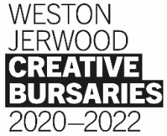
Weston Jerwood Creative Bursaries Programme 2020-22
This document is available to read in Easy Read format, listen to as an audio recording or watch in BSL video.

Cymraeg
Os byddai’n well gennych chi ddarllen fersiwn Cymraeg o’r testun hwn, cliciwch yma.
Os byddai’n well gennych chi wrando ar y testun hwn, cliciwch yma.
Os byddai’n well gennych chi weld fersiwn Hawdd i’w Ddarllen o’r testun hwn, cliciwch yma.

This job is part of a wider programme called the Weston Jerwood Creative Bursaries, which is designed and run by Jerwood Arts.

Who are we and what do we stand for?

Jerwood Arts is an independent arts funder, and we work with early-career artists, curators and producers to help them gain access to opportunities, collaborate with other artists and get ideas and projects off the ground. Sometimes we work with artists directly, and sometimes we work with organisations.
Together with organisations like the one you are considering applying to, we also advocate for the arts and cultural sector to be a more equitable and inclusive place to work. There is a wealth of information, data and academic research about the lack of diversity in the arts, and artists and arts workers continue to face exclusion based on their class origins, ethnicity, disability, gender, and other elements of their background, identity or experience. We think the system is broken, and that positive action combined with deep work by organisations is the only way for this to change. For this reason, the Weston Jerwood Creative Bursaries programme is only for those from low socio-economic backgrounds. It is also an Arts Council England Transforming Leadership programme, which is looking to nurture future leadership in the arts.
What is a low socio-economic background?
If you are from a low socio-economic background, you will most likely have been to state school, might have received free school meals as a child, or had a precarious household income when you were growing up. You might have grown up in the care system, been a young carer, or been the first in your family to go to university. Other terms people from a low socio-economic background might identify themselves with are working-class or benefit-class. If you are from a low socio-economic background you are more likely to face intersecting barriers in society, experiencing racism, ableism and other forms of discrimination. You can find out more about socio-economic diversity and inclusion, and the actions we are advocating for, in this Toolkit.

How it works

The programme funds year-long salaried jobs in arts and cultural organisations, as well as providing links to wider professional and pastoral guidance where it is needed. It seeks to interrogate and remove barriers to entry and enable people to build careers in the arts with confidence and support. Over 2020-2022, we are funding 50 jobs across a range of art forms – you can read about the full list of opportunities here.

What will you get from the programme beyond the job?
- Fellows Network: If you get this job, you will become part of a network with 49 other artists, curators and producers from low socio-economic backgrounds. We call this a network of ‘Fellows’. You will all be near the beginning of your life as professional artists and creatives, starting new jobs within three months of each other. It is likely that you might have faced similar and interconnecting barriers to working in the arts previously. Navigating institutions and new professional contexts can be tough, but you won’t be doing it alone. In the past the network has produced friendships, artistic collaborations, theatre companies and a sense of community.
- Professional Development: Fellows will join the Professional Development programme led by people make it work, which will provide support and training and will be co-created with you. This means that we will tailor the content to your needs, challenges and ambitions and work with you to ensure you learn exactly what you need to support your professional development. A key feature of this will be establishing the Fellows Network for shared learning. This programme will be delivered online, and we hope that at the end we can hold an event that brings the Fellows together in a physical space. The programme will take place over a series of live digital meetings that will enable you to get to know each other, meet and learn from alumni and share your experience of starting your new roles. These sessions will respond to your needs in terms of skills development and we imagine that some of the workshops might include networking and career progression, training as a freelancer, public speaking, CV writing and navigating organisations.
- Mentor: You will get a mentor (outside your Host organisation) to work with during your Fellowship. Who they are is completely up to you, and we will pay for their time. You’ll also receive guidance from Arts Emergency who have significant experience in how to identify and make the most of a mentor.
- Progression: Throughout the programme, you’ll be supported by your Host organisation and Jerwood Arts to help you work out your next steps after the year is over. This might be coaching, support with future job and funding applications, introductions to programmers and funders, or simply advice and encouragement. Jerwood Arts can provide £1,000 of additional funding specifically to support your own creative projects, research and collaborations towards the end of your time on the programme.
- Feedback: We’ve run this programme three times over the past decade (you can hear about other peoples’ experiences of the programme here). Each time we learn more about what works and what doesn’t, so you will be encouraged to speak to both Jerwood Arts and your Host organisation if there’s anything you’d like us to reflect on, build on or change to improve it for you.
If you love the sound of the job but have questions about the Weston Jerwood Creative Bursaries programme as a whole, you’re welcome to contact Sarah Gibbon, Project Manager at Jerwood Arts, confidentially on sarahg@jerwoodarts.org or 07944 903989 in advance of making an application.
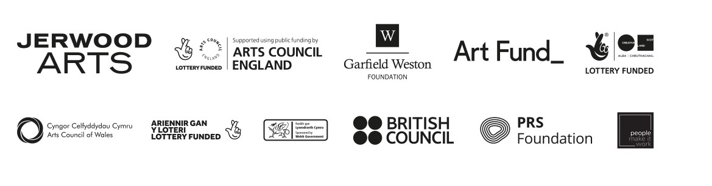
Please note that if your questions are specific to the job role or the application process, these should be directed to the organisation you’re applying to. You should find information about who to contact within the job pack.
The Weston Jerwood Creative Bursaries 2020-2022 programme is designed and produced by Jerwood Arts. It is funded and supported by Arts Council England’s Transforming Leadership Fund, Garfield Weston Foundation, Art Fund, Arts Council of Wales, The National Lottery through Creative Scotland, British Council, Jerwood Arts and PRS Foundation

