The Work Room Residency Programme

At the heart of The Work Room is our programme of supported, choreographic residencies. This programme supports experimentation and creative processes, from research through to production, according to the needs and requirements of each resident artist.

As an artists-led organisation, the selection process is peer-assessed with decisions taken by a working group of members. We take seriously our commitment to Equalities, Diversity and Inclusion and relish our responsibility to ensure an expansive range of artists and artistic practices are visible and supported. The Work Room seeks to foster a community of artists and we encourage all our residents to consider how they will share the findings of their residency time with our wider membership.

Our first deadline in 2020 is Monday 2 March for residencies for the period July to December 2020.

The next deadline is 2020 will be Monday 7 September to cover the period January – June 2021.

About

Residencies primarily take place in The Work Room studio in Tramway and are typically awarded in calendar weeks beginning on Mondays. Residents have exclusive access to the studio, green-room space and kitchen from 9am – 8pm Monday – Saturday and can choose to structure their time to suit their own schedules and project.

There is no obligation to offer a sharing or workshop as part of your residency, but members are encouraged to consider how they might engage with the wider membership. TWR will assist in publicising sharings, workshops, classes and other events members might wish to offer as part of their residency. The Work Room studio is situated in Tramway and is level accessible from the street to the studio. You can find more information about the studio facilities including access information, equipment and dimensions here .

Please be aware of the following when making an application for a residency with The Work Room:

- Only members of The Work Room are eligible to apply for a residency;

- Members may apply for only one residency during the six month residency period, but can be involved in other members’ applications as collaborators and/ or performers;

- To ensure a spread of residents, four weeks is the maximum duration of any one residency. Residencies tend to be awarded in week-long periods but we can be flexible in this to meet members’ needs;

- Due to the level of demand, unfortunately not all members who apply for a residency will be awarded one;

- All residencies are subject to programming availability and a degree of flexibility around dates may be required to help with the scheduling of residency time;

- Once a residency is agreed and confirmed in writing the dates may not be changed, unless in exceptional circumstances and where we can accommodate this without adverse terms for other residency users;

- A weekly bursary of £600 shall be made available to members awarded a residency (with the exception of any company who are in receipt of Regular Funding from Creative Scotland).

- The Work room is committed to improving the accessibility of our residency opportunities. We have an allocated access budget that can be utilised towards costs including additional support needs, specific travel requirements and childcare, for example.

Selection Process:

- All applications will be assessed by a panel of 4 – 5 people, drawn from the membership and chaired by Anita Clark, Director of TWR. Members who are not applying for a residency at the deadline will be invited to put themselves forward to be part of this;

- All applications will be assessed against the set criteria with decisions reflecting the majority opinion of the panel;

- All panel members will be asked to declare any interests or connections they may have with any of the residency applications at the start of the meeting. These will be discussed, and the panel decide how best to manage such an interest to avoid inappropriate or undue influence on decision making;

- The deadline of Monday 2 March is to consider residencies for the period July to December 2020. If you have a strong reason for applying now for a residency in 2021, the panel has the discretion to consider this in exceptional circumstances.

- Those unsuccessful will be given feedback and are welcome to apply to the next deadline

Residency Selection criteria:

Applications will be assessed primarily on:
- The clarity of the proposal or idea presented;
- The approach that will be taken through the residency to explore this;
- The potential for this residency to contribute to the on-going development of an artistic practice.

Through our programme, we aim to achieve a balance of:
- Research & development residencies through to those that support production;
- Shorter and longer residencies.

The final selection will also take into account:
- The amount of previous residency time awarded to the artist;
- Our aim to support a wide range of members and artistic practices; reflecting our membership in terms of aesthetic, dance style/genre, gender and stage of career.

How to Apply:

You can apply for a residency by either submitting a written application, video or downloading and completing an application form. The deadline for all applications is Monday 2 March.

If require support in preparing or submitting an application, please contact us directly on hello@theworkroom.org.uk or by calling +44 (0) 141 423 3864 .

Written Application

In your application please provide information in response to the questions outlined below. Written applications should be submitted using no more than 2 pages of A4. There is no need to include a CV or biography, but please do ensure that your profile on The Work Room’s members web-page is up-to-date as the panel will be asked to refer to this for information on your practice.

In your application, please tell us the following

- The idea or project that you wish to develop through a residency

- Why this idea or project is important to you and why now is the right time to work on it? If you are applying for a longer or split residency you should use this question to explain why.

- What you hope to achieve or discover by the end of your time in residence?

- How working on this idea or project at this time will contribute to your wider practice and future plans?

- Please tell us about your current involvement in The Work Room and how you would propose to share your residency experience or findings with the wider membership?

You should also include:

- How long would you like to be in residence and at what time?

- If you are planning on working with other dance artists or collaborators during your residency, please tell us how this will be financed?

- Any access requirements you may have to support you to undertake the residency; this may include interpretation, Personal Assistance support, specific transport requirements and/ or childcare.

- What, if any factors, might prevent you from taking up the offer of space in the studio?

Applications should be uploaded as Word or PDF documents through our website by Monday 2 March 2020. All applicants will be notified of the decisions by end of March.

Video Application

If you are applying by video, please note that the video doesn’t need to be professionally edited or cut but you should ensure it is shot in a well-lit location and any sound is clear and audible. You should begin your video by stating:

- your name
- the number of weeks you are applying for and any preference of dates
- Any access requirements or support you require to undertake a residency
- Any foreseeable factors that might prevent you taking up an offer of space in the studio
If you are applying for a residency with other dance artists or collaborators you should also state-

- Who they are
- How this will be financed

In your video you should answer the following questions spending no more time than 1 minute on each question
- What is the idea or project that you wish to develop through a residency?

- Why is this idea or project important to you and how will it contribute to your wider practice?

- What do you hope to achieve or discover during your time in residence?

- Why is now the right time to work on this project and how does it contribute to your future plans? If you are applying for a longer or split residency you should also use this question to explain why.

- Please tell us about your current involvement in The Work Room and how you would propose to share your residency experience or findings with the wider membership?
Videos should be uploaded to a hosting site such as Vimeo or YouTube. To submit your application please go to our website and paste a link to your video link along with any password required in the Submissions portal by Monday 2 March 2020. There is no need to include a CV or biography, but please do ensure that your profile on The Work Room’s members web-page is up-to-date as the panel will be asked to refer to this for information on your practice.

Application Form

An application form with the relevant questions can be downloaded here. Completed applications should not exceed 3 pages. To submit your application please upload your form as a Word or PDF document through our website by Monday 2 March 2020There is no need to include a CV or biography, but please do ensure that your profile on The Work Room’s members web-page is up-to-date as the panel will be asked to refer to this for information on your practice.

All applicants will be notified of the decisions by end March 2020
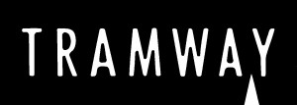
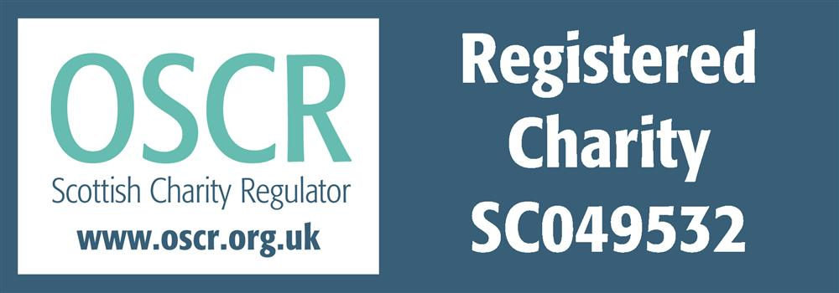

The Work Room (Dance) is a limited company by guarantee with charitable status, registered in Scotland with Company No SC343929 and
registered Scottish Charity No SC049532 with its registered office at
Tramway, 25 Albert Drive, Glasgow G41 2PE

