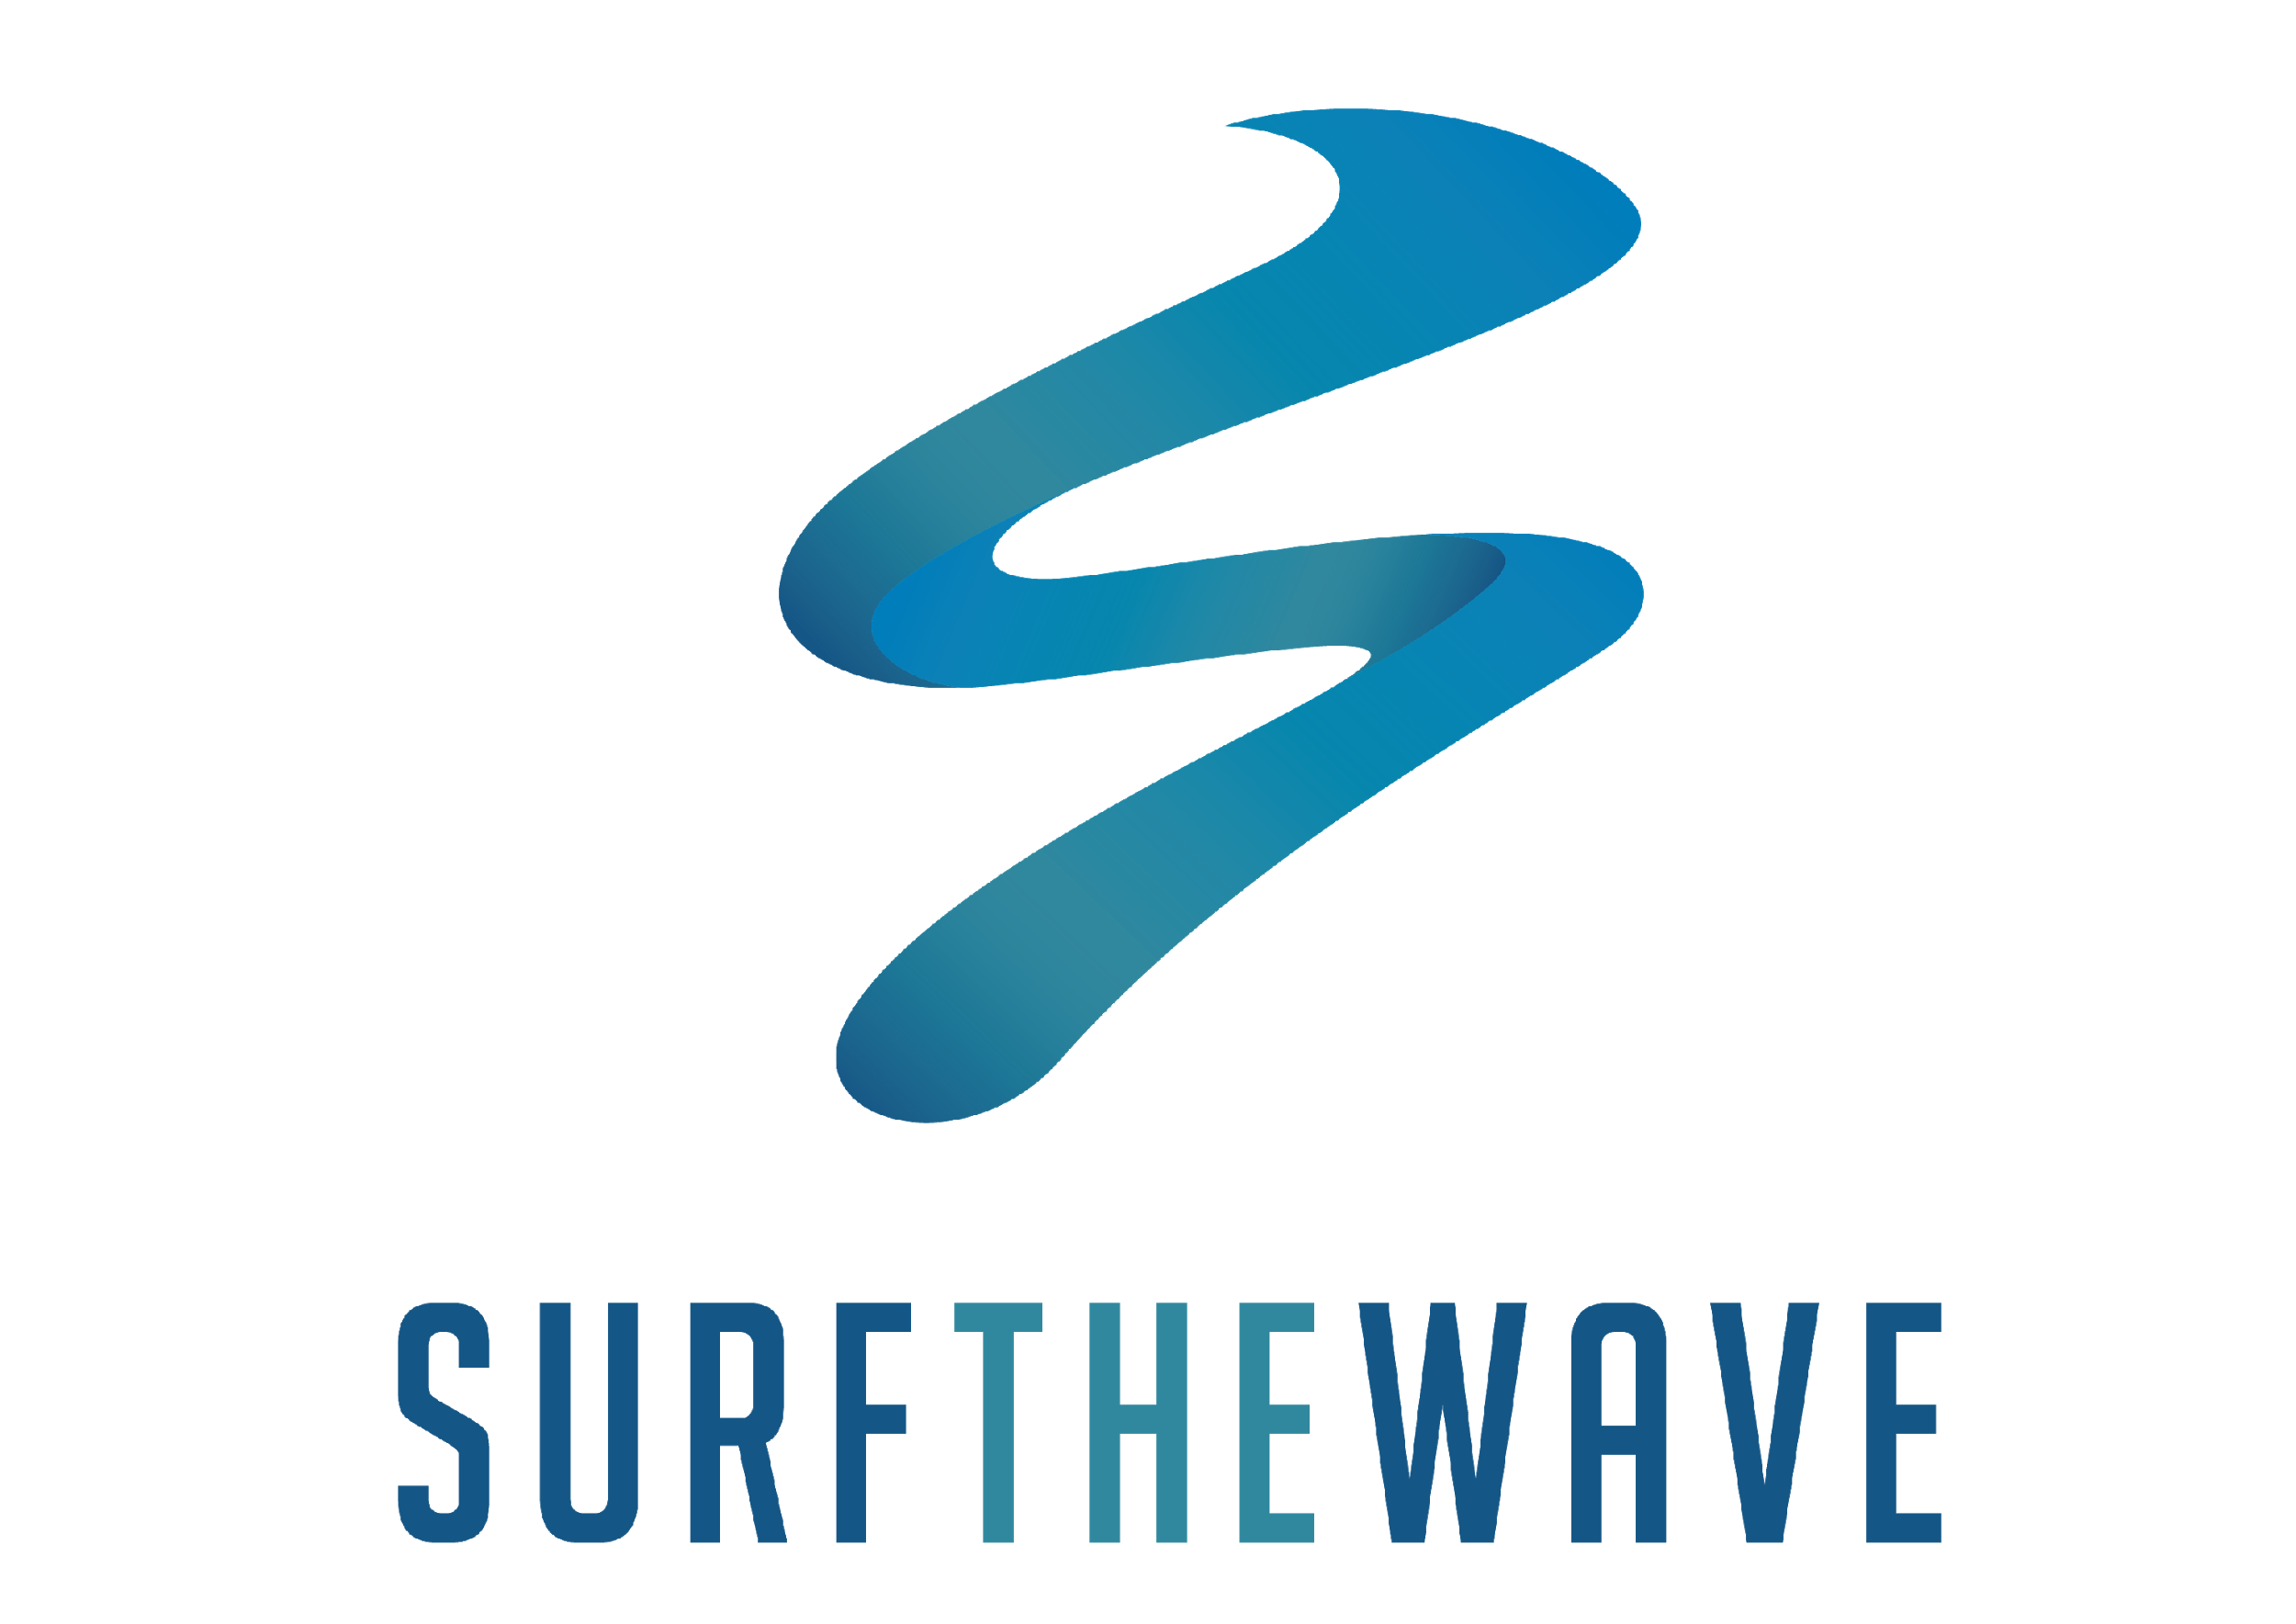
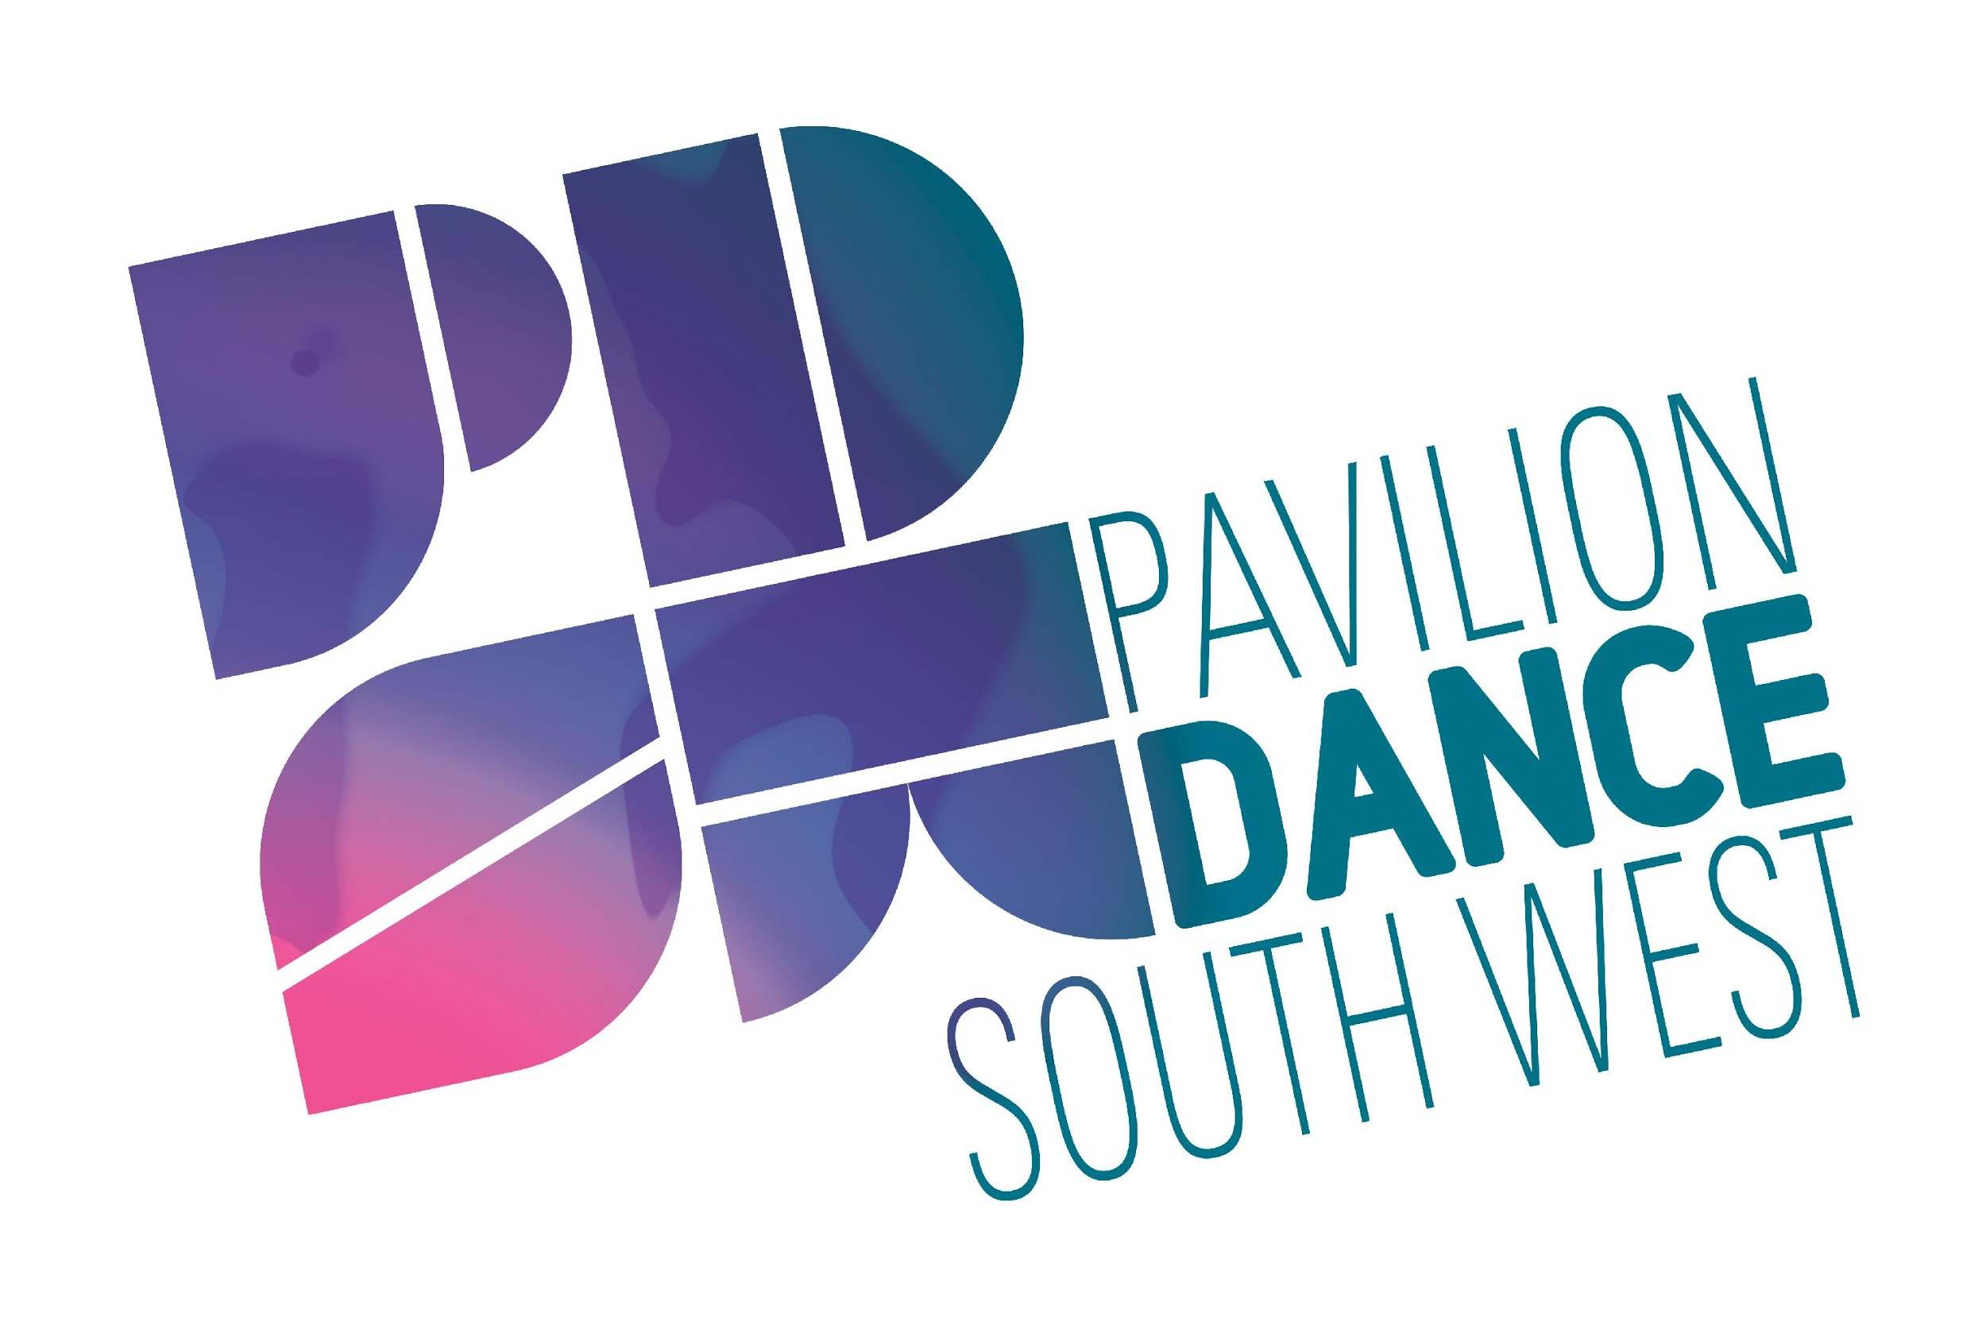
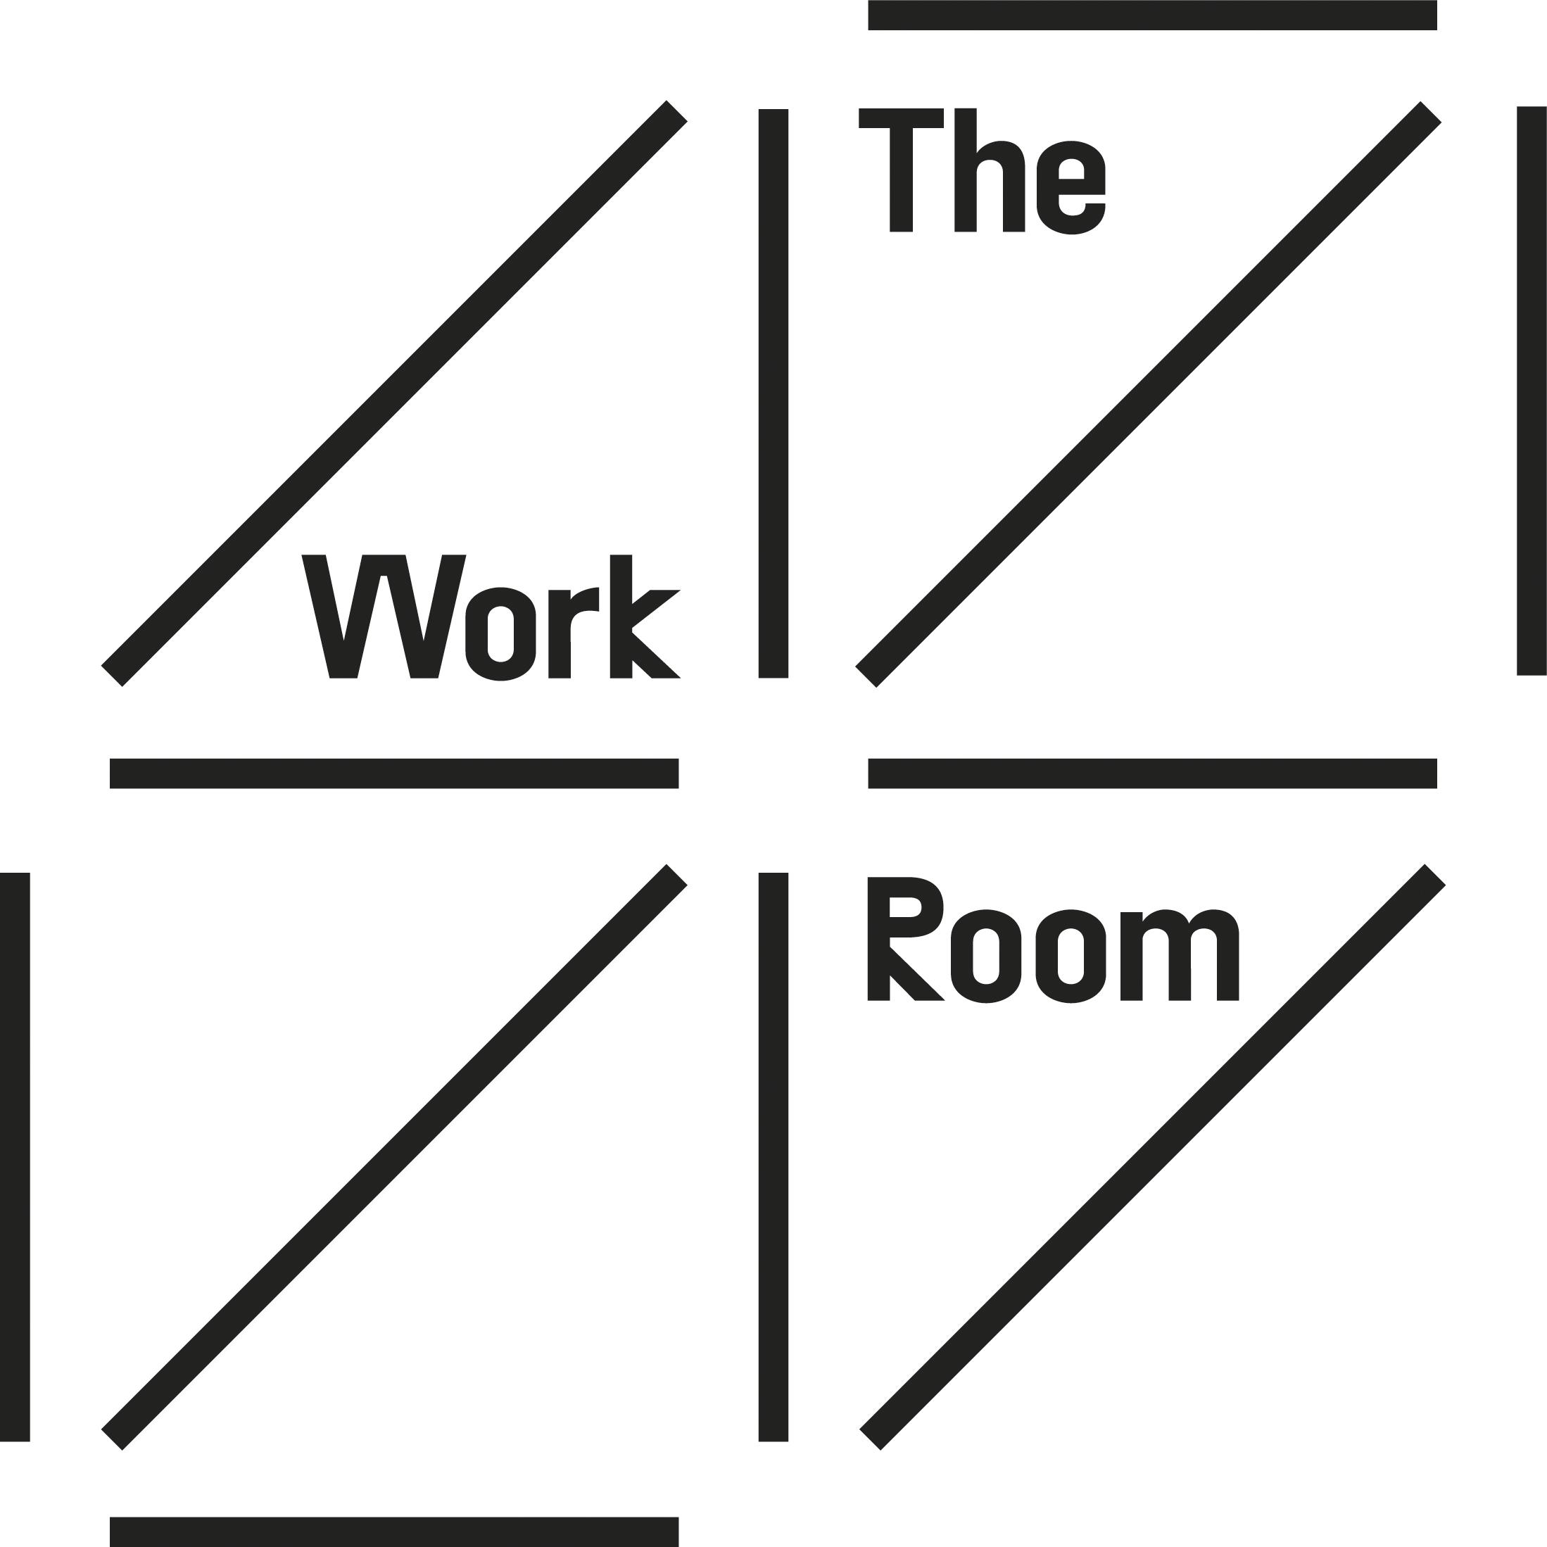

Application Form for Surf the Wave in Scotland- Artists and Producers

Please complete all sections of the application form below. If you would like this application in a different format or would like to apply in a different format, please contact stwcoordinator@pdsw.org.uk

Artist/Company Details
Name: |  | Company Name (if relevant):
Address: |  | Post Code:
Funding Base (ACE region/ Creative Scotland/ ACW-This can be your base or where support is accessed.) |  | Email Address:
Home/Work Phone: |  | Mobile Phone:
Name of Company Producer: |  | Will your Producer attend also? | Yes/No
Why do you want to participate in the Surf the Wave in Scotland Intensive (Maximum 100 words)
Please outline your 2 most recent independent productions and tours. How many dates were in your tours? How were they funded? ( Maximum 100 words)
Have you got a concept or work in progress that could be ready to tour in 2019? If yes, please give brief details (Maximum 100 words):

Please provide links to online videos of your work below. These can be on YouTube or Vimeo:

Please indicate your choice of event:
Location | Date | Please tick preferred event:
Eden Court, Inverness | 21 February 2019
Macrobert Arts Centre, Stirling | 1 March 2019

Please indicate if you would like to apply for a bursary to attend | yes/ no
Please indicate if you producer is attending and would also like to apply for a bursary | yes/ no

Please email your completed application form along with a completed equal opportunities form* to: stwcoordinator@pdsw.org.uk with the subject heading “Application – Surf the Wave in Scotland *The equal opportunities form can be accessed via our website. We would really appreciate you completing and returning this form as it helps us with monitoring and data for our stakeholders, and to ensure we are reaching as far as possible with this project. These will separated from your application before short listing.
Deadline for applications: 9am, Friday 2nd November 2018
Applicants will be notified by 30th November 2018

Surf the Wave is supported by:

